Presented below is the year-end 2005 balance sheet for The Little Corporation.

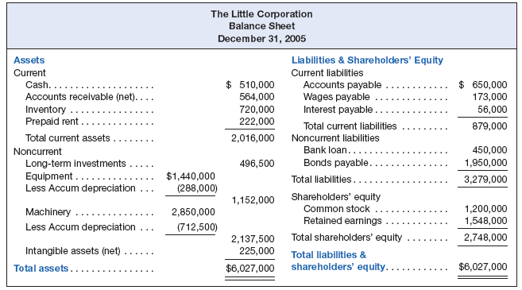

During 2006, the company entered into the following events:
✔

1. Sales to customers totaled $2 million, of which $1.6 million were on credit and the remainder was cash sales. The cost of goods sold totaled $800,000.

2. Purchased $700,000 of inventory on credit.

3. Paid $620,000 cash to employees as wages. (This amount includes the wages payable at December 31, 2005.)

4. Collected $1.75 million cash from customers as payment on outstanding accounts receivable.

5. Paid $1.2 million cash to suppliers on outstanding accounts payable.

6. Sold machinery for $120,000 cash on January 1, 2006. The machinery had cost $370,000 and at the time of sale it had a net book value of $160,000.

7. Paid miscellaneous expenses totaling $98,000 cash.

8. Sold common stock for $450,000 cash.

9. Invested $200,000 of excess cash in short-term marketable securities.

10. Declared and paid a cash dividend of $100,000.
As part of the year-end audit, the internal audit staff identified the following additional information:

1. $180,000 of prepaid rent was consumed during the year.

2. The equipment had a useful life of ten years and the machinery of 20 years. The company uses straight-line depreciation. (No depreciation should be recorded for machinery in Item 6 above.)

3. The intangible assets had a remaining useful life of ten years.

4. Interest on the bank loan and bonds payable was ten percent. During the year, interest payments totaling $260,000 had been paid in cash.

Required

1. Using the balance sheet equation as illustrated in this chapter, prepare a spreadsheet reflecting the events of the Little Corporation during 2006.

2. Prepare the income statement for 2006.

3. Prepare the statement of shareholders’ equity, balance sheet, and statement of cash flow for 2006.

4. How has the company’s use of leverage changed from 2005 to 2006?

