I'm having a hard time understand how to solve these problems. The textbook provides the answers. But I need help understanding the step to get to the answer. Also, some of the images maybe be slightly misfigured. I had a hard time cut and pasting the images. If possible please provide diagrams on how you got the solutions. Thank you.
Answers
- 2100 lb.
- 845 N.
- 37.0°.

- A crate is supported by three cables as shown. Determine the weight of the crate knowing that the tension in cable AB is 750 lb.
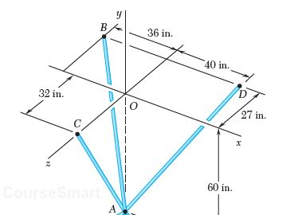
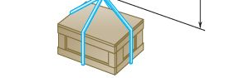

- A rectangular plate is supported by three cables as shown. Knowing that the tension in cable AC is 60 N, determine the weight of the plate. (480 is cut off)

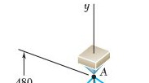
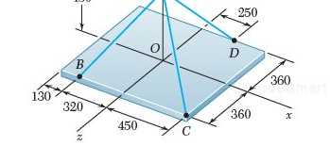

- The direction of the 75- lb forces may vary, but the angle between the forces is always 50°. Determine the value of a for which the resultant of the forces acting at A is directed horizontally to the left.
