I'm having a hard time understand how to solve these problems. The textbook provides the answers. But I need help understanding the step to get to the answer. ALso some of the images maybe be slightly misfigured. I had a hard time cut and pasting the images. If possible please provide diagrams on how you got the solutions. Thank you.

answers:
- a) 100N
- ( a ) 41.7N x m . ( b ) 147.4N a 45.0°.
- 1224 N
- ( 492lb x ft) i + ( 144.0lb x ft) j - ( 372lb x ft) k .

- A horizontal circular plate is suspended as shown from three wires that are attached to a support at D and form 30° angles with the vertical. Knowing that the z component of the force exerted by wire BD on the plate is -32.14 N, determine ( a) the tension in wire BD,
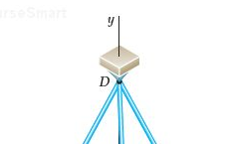

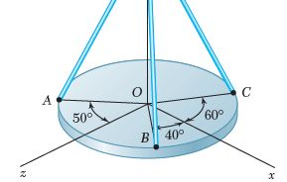

2. A 300- N force is applied at A as shown. Determine (a) the moment of the 300- N force about D, ( b) the smallest force applied at B that creates the same moment about D.
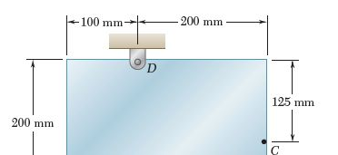

3. It is known that a force with a moment of 960 N x m about D is required to straighten the fence post CD. If d = 2.80 m, determine the tension that must be developed in the cable of winch puller AB to create the required moment about point D.
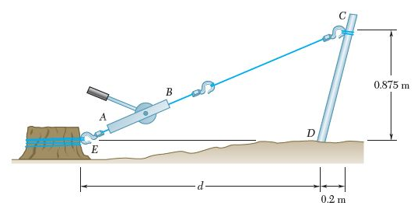
4. A small boat hangs from two davits. The tension in line ABAD is 82 lb. Determine the moment about C of the resultant force Ra exerted on the davit at A.

