7) Use figure 2 below to answer to the following question:
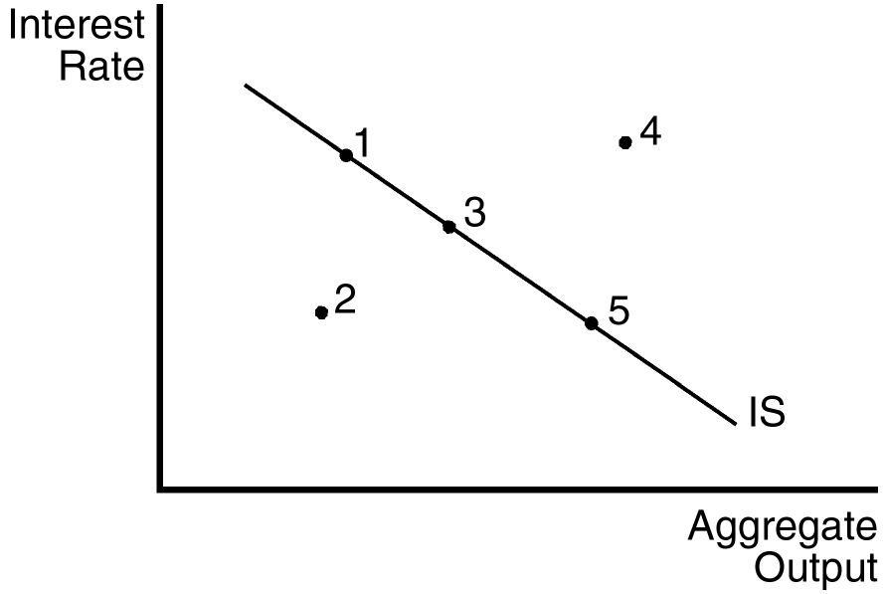

Indicate where the economy is located if aggregate output is above the level of planned spending and if aggregate output is above the equilibrium level of output.

