1.
What is missing in this surface of revolution as a function of x revolved around the y-axis: ?
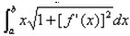
A) Nothing, the formula is fine as is.
B) Nothing, but the limits of integration should be on the interval [c, d].
C) The variable x should be x2.
D) The constant 2π is missing.
2.
Find the solid of revolution for f(x) = x² and g(x) = ½x³ for x∈[2, 3].
A) 31.34
B) 9.97π
C) 31.34π
D) 1.46π
3.
What are the coordinates of the centroid for f(x) = x ∀∈[0, 2]?
A) (4/3, 2/3)
B) (4, 2)
C) (8/3, 4/3)
D) (16/9, 4/9)
4.
∫h(x) dx is determined to be an improper integral due to its upper limit, L. How is this problem re-expressed so that it can be properly evaluated?
A) There is no way to know.
B) 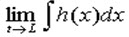
C) 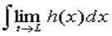
D) Becaue it is an improper integral, it cannot be properly evaluated.
5.
What was the conversion described in the text in the discussion of the amount of work needed to list a satellite into orbit?
A) Multiply by 1.8 and then add 32
B) Divide by 5280
C) Multiply by 2.54
D) Multiply by 5280
6.
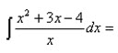
A) ½x2 + 3x - 4ln(x) + C
B) ln(x2 + 3x - 4) + C
C) x2 + 3x - ln(4x) + C
D) Cannot be integrated.
7.
About which axis is this surface revolved?
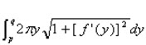
A) The x-axis.
B) The y-axis.
C) The axis determined by the line y = x.
D) It's not revolved around any axis, this is the formula for arc length.
8.
Complete the square for this function:
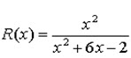
A) It's already been completed, it's x².
B) (x + 3)² − 11
C) (x + 3)² − 7
D) 2x² + 6x − 2

9.
How much total work is expended over a 10-minute period if the force function is given by F(t) = 4t³ - 6t² - 5t?
A) 7750 units
B) 3350 units
C) 3875 units
D) This problem in indeterminate.

10.
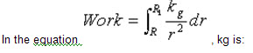
A) R2•F(R).
B) the spring constant.
C) the constant of integration.
D) 4π + r.
11.
If an improper integral is found to have a finite solution, then:
A) The solution will always be some multiple of π.
B) You've done something wrong.
C) The function being integrated converges.
D) The function being integrated diverges

