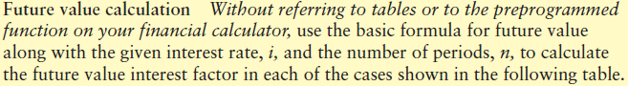
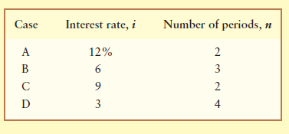
2 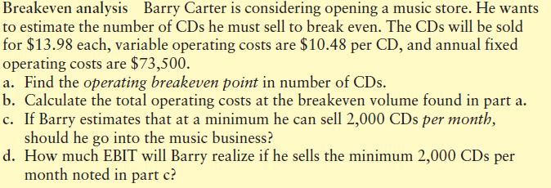
3 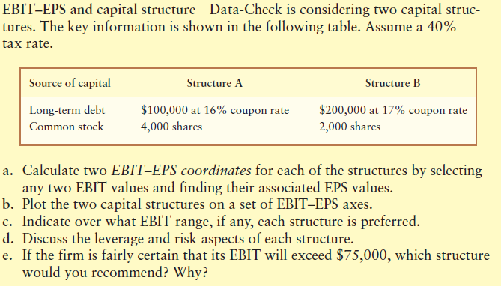
4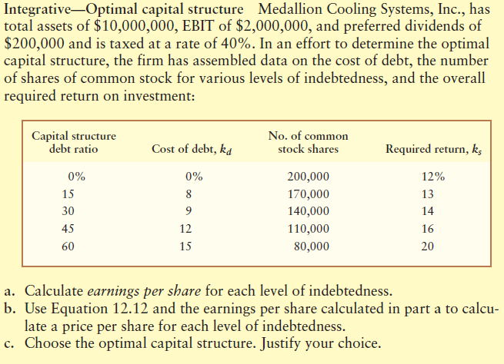

1. A financial analyst is responsible for maintaining and controlling the firm’s daily cash balances. Frequently manages the firm’s shortâ€‘term investments and coordinates shortâ€‘term borrowing and banking relationships.

2. Finance is concerned with the process institutions, markets, and instruments involved in the transfer of money among and between individuals, businesses and government.

3. Financial services are concerned with the duties of the financial manager.

4. Financial managers actively manage the financial affairs of many types of business—financial and non-financial, private and public, for-profit and not-for-profit.

5. In partnerships, owners have unlimited liability and may have to cover debts of other less financially sound partners.

6. In partnerships, a partner can readily transfer his/her wealth to other partners.

7. The board of directors is responsible for managing dayâ€‘toâ€‘day operations and carrying out the policies established by the chief executive officer.
8. Since individuals are always confronted with opportunities to earn positive rates of return on their funds, the timing of cash flows does not have any significant economic consequences.

9. Timeâ€‘value of money is based on the belief that a dollar that will be received at some future date is worth more than a dollar today.

10. Future value is the value of a future amount at the present time, found by applying compound interest over a specified period of time.

11. Interest earned on a given deposit that has become part of the principal at the end of a specified period is called compound interest.

12. The future value interest factor is the future value of $1 per period compounded at i percent for n periods.

13. For a given interest rate, the future value of $100 increases with the passage of time. Thus, the longer the period of time, the greater the future value.

14. The greater the potential return on an investment and the longer the period of time, the higher the present value.
15. For the risk-seeking manager, no change in return would be required for an increase in risk.

16. For the risk-averse manager, the required return decreases for an increase in risk.

17. For the risk-indifferent manager, no change in return would be required for an increase in risk.

18. Most managers are riskâ€‘averse, since for a given increase in risk they require an increase in return.

19. The return on an asset is the change in its value plus any cash distribution over a given period of time, expressed as a percentage of its ending value.

20. The real utility of the coefficient of variation is in comparing assets that have equal expected returns.

21. An investment that guarantees its holder $100 return and another investment that earns $0 or $200 with equal chances (i.e., an average of $100) over the same period have equal risk.
22. Real rate of interest is the actual rate of interest charged by the suppliers of funds and paid by the demanders.

23. The longer the maturity of a Treasury (or any other) security, the smaller the interest rate risk.

24. A downwardâ€‘sloping yield curve indicates generally cheaper shortâ€‘term borrowing costs than longâ€‘term borrowing costs.

25. The nominal rate of interest is the rate that creates equilibrium between the supply of savings and the demand for investment funds in a perfect world, without inflation, where funds suppliers and demanders have no liquidity preference and all outcomes are certain.

26. An inverted yield curve is an upward-sloping yield curve that indicates generally cheaper short-term borrowing costs than long-term borrowing costs.

27. Although Treasury securities have no risk of default or illiquidity, they do suffer from “maturity risk”—the risk that interest rates will change in the future and thereby impact longer maturities more than shorter maturities.

28. Liquidity preference theory suggests that for any given issuer, longâ€‘term interest rates tend to be higher than shortâ€‘term rates due to the lower liquidity and higher responsiveness to general interest rate movements of longerâ€‘term securities; causes the yield curve to be upwardâ€‘sloping.
29. Holders of equity have claims on both income and assets that are secondary to the claims of creditors.

30. The tax deductibility of interest lowers the cost of debt financing, thereby causing the cost of debt financing to be lower than the cost of equity financing.

31. Preferred stock is a special form of stock having a fixed periodic dividend that must be paid prior to payment of any interest to outstanding bonds.

32. Cumulative preferred stocks are preferred stocks for which all passed (unpaid) dividends in arrears must be paid in additional shares of preferred stock prior to the payment of dividends to common stockholders.

33. Preferred stock is often considered a quasiâ€‘debt since it yields a fixed periodic payment.

34. The amount of the claim of preferred stockholders in liquidation is normally equal to the market value of the preferred stock.

35. Cumulative preferred stocks are not preferred stocks for which all passed (unpaid) dividends in arrears must be paid along with the current dividend prior to the payment of dividends to common stockholders.
36. The breakeven cash inflow is the minimum level of cash inflow necessary for a project to be acceptable.

37. Projects with a small chance of being acceptable and a broad range of expected cash flows are more risky than projects having a high chance of being acceptable and a narrow range of expected cash flows.

38. In capital budgeting, risk refers to the chance that a project has a high degree of variability of the initial investment.

39. Sensitivity analysis is a behavioral approach that uses a number of possible values for a given variable to assess its impact on a firm’s return.

40. Sensitivity analysis is a statistically based approach used in capital budgeting to get a feel for risk by applying predetermined probability distributions and random numbers to estimate risky outcomes.

41. Scenario analysis is an approach that uses a number of possible values for a given variable in order to assess its impact on a firm’s return.

42. Simulation is an approach that evaluates the impact on return of simultaneous changes in a number of variables.
43. Generally, increases in leverage result in increased return and risk.

44. Breakeven analysis is used by the firm to determine the level of operations necessary to cover all fixed operating costs and to evaluate the profitability associated with various levels of sales.

45. The firm’s operating breakeven point is the level of sales necessary to cover all fixed operating costs.

46. Leverage results from the use of fixed-cost assets or funds to magnify returns to the firm’s owners.

47. Operating leverage is concerned with the relationship between the firm’s sales revenue and its operating expenses.

48. Financial leverage is concerned with the relationship between the firm’s earnings after interest and taxes and its common stock earnings per share.

49. Total leverage is concerned with the relationship between the firm’s sales revenue and its common stock earnings per share.
50. A firm that is unable to pay its bills as they come due is technically insolvent.

51. The short-term financial management is concerned with management of the firm’s current assets and current liabilities.

52. In the short-term financial management, the goal is to manage each of the firm’s current assets and current liabilities in order to achieve a balance between profitability and risk that contributes to the firm’s value.

53. Working capital represents the portion of the firm’s investment that circulates from one form to another in the long-term conduct of business.

54. In general, the more a firm’s current assets cover its short-term obligations, the better able it will be to pay its bills as they come due.

55. The more predictable its cash inflows, the more net working capital a firm needs.

56. As the ratio of current assets to total assets increases, the firm’s risk increases.

57. Accounts payable are spontaneous secured sources of short-term financing that arise from the normal operations of the firm.

58. Notes payable can be either spontaneous secured or spontaneous unsecured financing and result from the normal operations of the firm.

59. Accounts payable result from transactions in which merchandise is purchased but no formal note is signed to show the purchaser’s liability to the seller.

60. In credit terms, EOM (End-of-Month) indicates that the accounts payable must be paid by the end of the month in which the merchandise has been purchased.

61. Accruals are liabilities for services received for which payment has yet to be made.

62. The cost of giving up a cash discount is the implied rate of interest paid in order to delay payment of an account payable for an additional number of days.

63. In giving up a cash discount, the amount of the discount that is given up is the interest being paid by the firm to keep its money by delaying payment for a number of days.
64. NAFTA is a treaty establishing free trade and open markets between Europe and the United States.

65. The World Trade Organization is a new international body established to police world trading practices and to mediate disputes between member countries.

66. Offshore Centers are cities or states that have achieved prominence as major centers for Euromarket business.

67. NAFTA is an international financial market that provides for borrowing and lending currencies outside their country of origin.

68. Fluctuations in foreign exchange markets can affect foreign revenues and profits of a multinational company, but they have no impact on its overall value.

69. The Euromarket is the international financial market that provides for borrowing and lending currencies outside their country of origin.

70. The existence of specific regulations and controls on dollar deposits in the United States, including interest rate ceiling imposed by the government, have contributed to the growth of the Euromarket.

