**1)** Given the following data:

**Year 1** **Year 5**

Consumption 600 960

Investment 134 340

Property Income earned overseas 75 120

Property income paid overseas 95 95

Subsidies 55 110

Indirect Taxes 85 150

Exports 80 150

Imports 105 125

Depreciation 70 90

Government Spending 280 270

**Calculate** **for both years**:

1- GDP at market prices

2- GNP at market prices

3- GNP at factor cost

4- Net National Product

5- National Income

**2)** Consider the following graph, and determine the equilibrium level of income algebraically.



(AE = Total Spending, AP = Total Production or Total Output)(Hint: **The equilibrium level exists where AE = AP. Graphically, this is expressed at the point of intersection between the AE and AP curves. In this problem, consumption spending is the only component of AE. Therefore, equilibrium exists where the expenditures function intersects the AP curve (the 45 degree line).**

**3)** Use figure 2 below to answer to the following question:

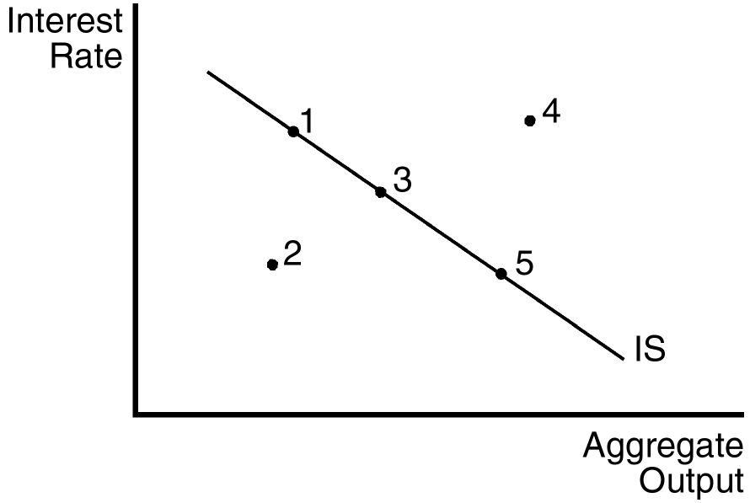

Indicate where the economy is located if aggregate output is above the level of planned spending and if aggregate output is above the equilibrium level of output.

**4)**

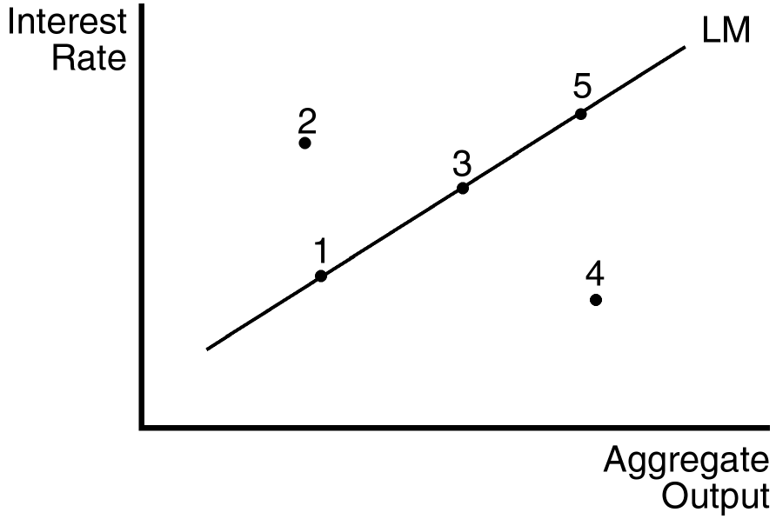

5) Use the graph to indicate where the economy is located if the interest rate is below the equilibrium level and people are holding less money than they desire.

**9)** Consider the following data for the United States and Switzerland:

GDP Deflator Switzerland GDP Deflator United States Market Exchange Rate

1980 85.7 76.0 2.49 francs/$

1990 113.4 119.6 2.12 francs/$

Compute the real exchange rate for 1980 and 1990.

(Real exch. rate = (exch. Rate*U.S. price index)/foreign price index)