1) The following graph shows the depreciation for the corporate airplane from 2006 to 2009. The plane was purchased new in 2006; therefore, x = 0 represents the year 2006.
X – axis (horizontal) = years starting from 0 = 2006 and increasing by 0.5 years
Y – axis (vertical) = price in $ amounts
You can click and drag the graph to enlarge it if it will make it easier for you to read.
a) List the coordinates of two points on the graph in (x, y) form.
(___, ___),(___, ___)
b) Find the slope (rate of depreciation) of this line:
Answer:

Show your work here:
c) Find the equation of this line in slope-intercept form.
Answer:
Show or explain your work here:
d) If the rate of depreciation continues at the present rate, what will be the plane’s value in the year 2017? Show how to use the equation from part c) to obtain your answer.
Answer:
Show or explain your work here:

2) Suppose that the width of a rectangle is 5 inches shorter than the length and that the perimeter of the rectangle is 50 inches. The formula for the perimeter of a rectangle is P=2L+2W.
a) Set up an equation for the perimeter involving only L, the length of the rectangle.
Answer:
b) Solve this equation algebraically to find the length of the rectangle. Find the width as well.
Answer: Length ______, Width ______
Show your work here:

3) A marketing group developing online ad space is offering two payment options:
Option 1: $300 set up fee plus $10/inch of the ad
Option 2: No set up fee but $25/inch of the ad.
Let x = inches of the proposed ad, for example, x = 2 for a column ad that is 2” long.
- Write a mathematical model representing the total ad cost, C, in terms of x for the following:
Option 1: C=_________________
Option 2: C=_________________
- How many inches of ad space would need to be purchased for option 1 to be less than option 2? Set up an inequality and show your work algebraically using the information in part a. Summarize your findings in a brief sentence.
Answer:
Show your work here:

4) Use the graph of y = x² + 4x - 5 to answer the following:

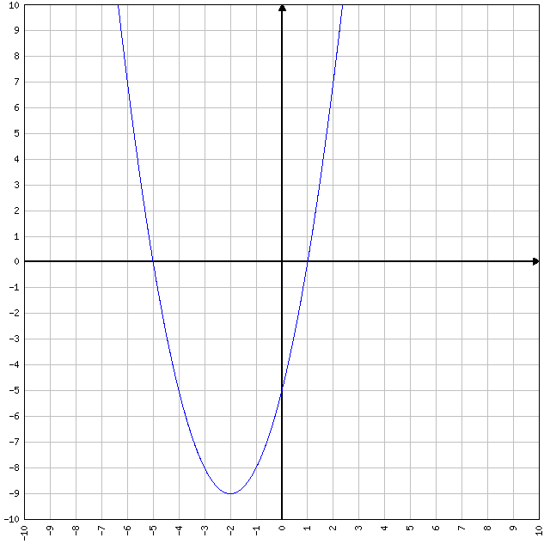
a) Without solving the equation or factoring, determine the solution(s) to the equation, , using only the graph.

Answer:
Explain how you obtained your answer(s) by looking at the graph:

b) Does this function have a maximum or a minimum?

Answer:
Explain how you obtained your answer by looking at the graph:

c) What are the coordinates of the vertex in (x, y) form?
Answer:

d) What is the equation of the line of symmetry for this graph?

Answer:

5) The profit function for Wannamaker Trophies is P(x) = -0.3x² + fx - m, where f represents the design fee for a customer’s awards and m represents the monthly office rent. Also, P represents the monthly profit in dollars of the small business where x is the number of awards designed in that month.

a) If $60 is charged for a design fee, and the monthly studio rent is $1,500; write an equation for the profit, P, in terms of x.

Typing hint: Type x-squared as x^2

Answer:

b) How much is the profit when 50 award designs are sold in a month?
Answer:
Show your work here:

c) How many award designs must be sold in order to maximize the profit? Show your work algebraically. Trial and error is not an appropriate method of solution –
use methods taught in class.

Answer:
Show your work here:

d) What is the maximum profit?
Answer:
Show your work here:

6. Graph the equations on the same graph by completing the tables and plotting the points. You may use Excel or another web-based graphing utility.

a) y = -2x + 7
Use the table; find at least 3 points using any values for x.
x | y

b) y = x² – 4x
Use the values of x provided in the table.
x | y
0
1
2
3
4

