)
Use Figure 8.2, which represents the situation faced by a monopolist, to answer questions a-c.

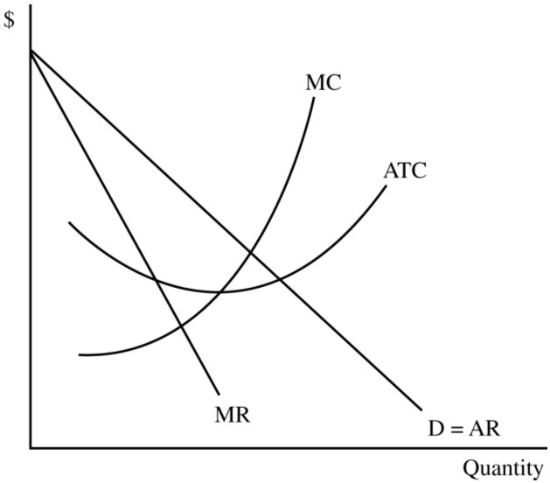
Figure 8.2

a. In Figure 8.2, indicate the profit maximizing price and output level and label them P1 and Q1.

b. Shade in the area that represents the firm's economic profit (or loss).

c. If this firm wished to discourage entry by other firms it could produce the output level at which it earns only a zero economic profit. Indicate the price and output level associated with a zero economic profit and label them P2 and Q2.

2)

