Homework Algebra 10

The height of a rocket is given by the equationwhere the height is measured in feet above the ground and the time, t, is measured in seconds. How long will it take for the rocket to hit the ground?

Ann has a 32 oz. bowl of M&Ms on her coffee table. The candies are 50% blue M&Ms.
She eats some of the M&Ms (which are 50% blue), then fills the bowl back to 32 oz. with a package of M&Ms that contains 20% blue ones.
If the resulting full bowl (32 oz.) contains 40% blue M&Ms, how many ounces did she eat?

A cone has volume 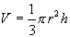where r is the radius of the base and h is the height. If a cone has a volume cm³ and the radius is 9 centimeters, find its height.

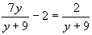
Solve for y:

A playground is in the shape of a trapezoid, with the longer parallel side twice as long as the shorter side and the height equal to the length of the shorter side. If the area of the playground is 66,150 m², find the length of the shorter parallel side.
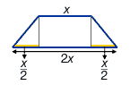

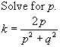
Find the length of the three equal sides of an equilateral triangle with height 11 units.
