Details Surrounding the Purchase of Ownership
Leeds has decided to purchase Emily and Richard’s 80% ownership of Faster Distribution Company for $90,000 in excess of book value.
Faster’s financial statement is as follows:
Faster Distribution Company Incorporated
Financial Statements
as of 12/31/XX
Assets
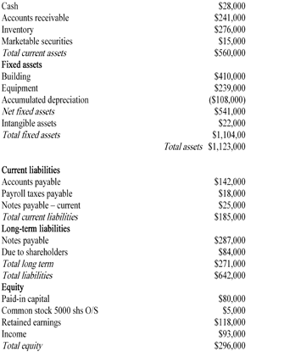
During their review of the Leeds’ purchase of Faster, it is revealed that Faster paid $125,000 to a German politician to allow the purchase to proceed. Moreover, Faster’s plant manager paid $2,000 to a German port official to allow a rice shipment to be completed.

