4. Individual Assignment: Problem Sets – Comprehensive
Due Date: 7/6

- Ch. 3, p. 95 – exercise 88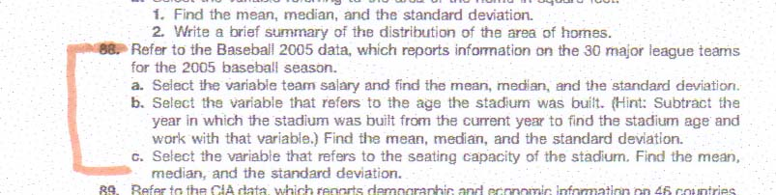
- Ch. 5, p. 173 – exercise 56

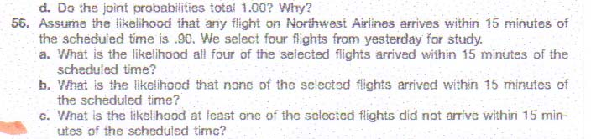

- Ch. 6, p. 217 – exercise 64
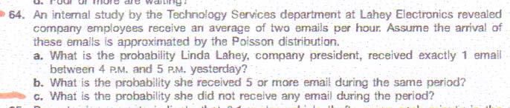

- Ch. 7, p. 249 – exercise 50
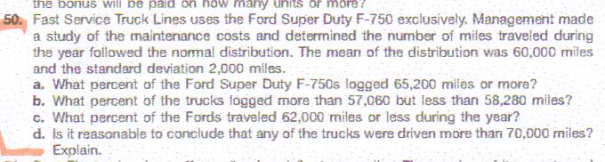
o Ch. 8, p. 288 – exercise 38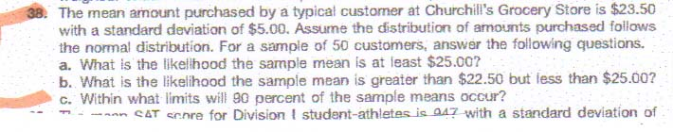
o Ch. 9, p. 321 – exercise 54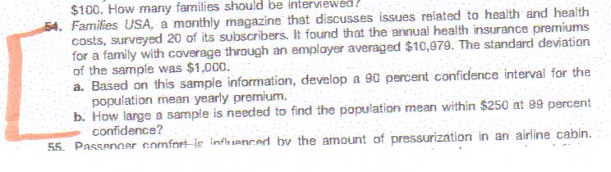
o Ch. 10, p. 362 – exercise 42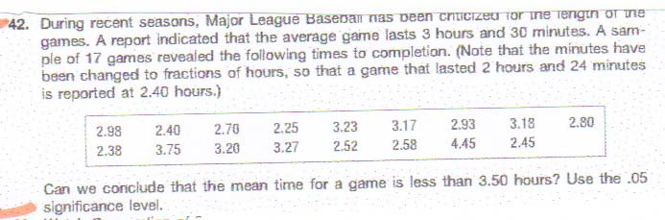
- Ch. 11, p. 402 – exercise 58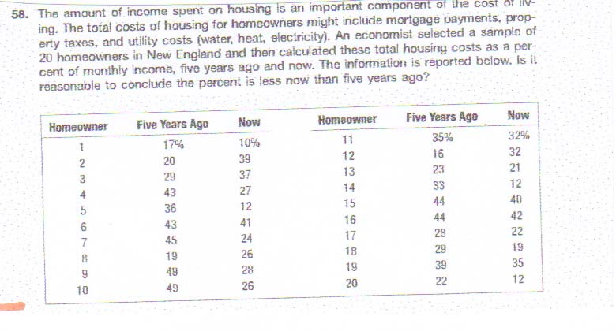

- Ch. 12, p. 445 – exercise 42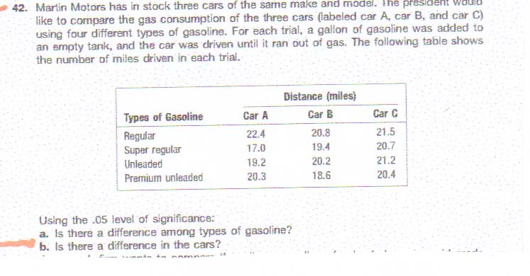

- Ch. 13, pp. 499 – exercise 37, 40
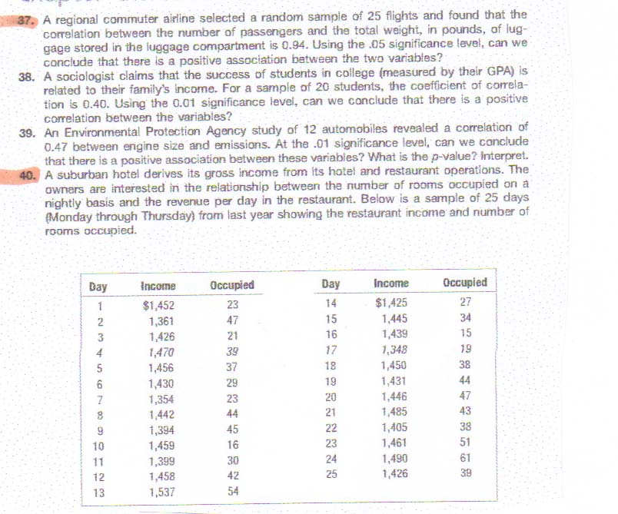

- Ch. 14, pp. 548-49 – exercise 17, 18
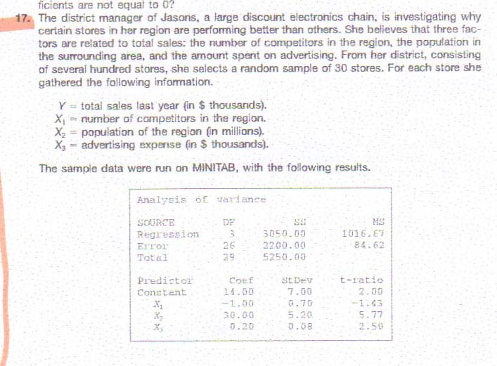
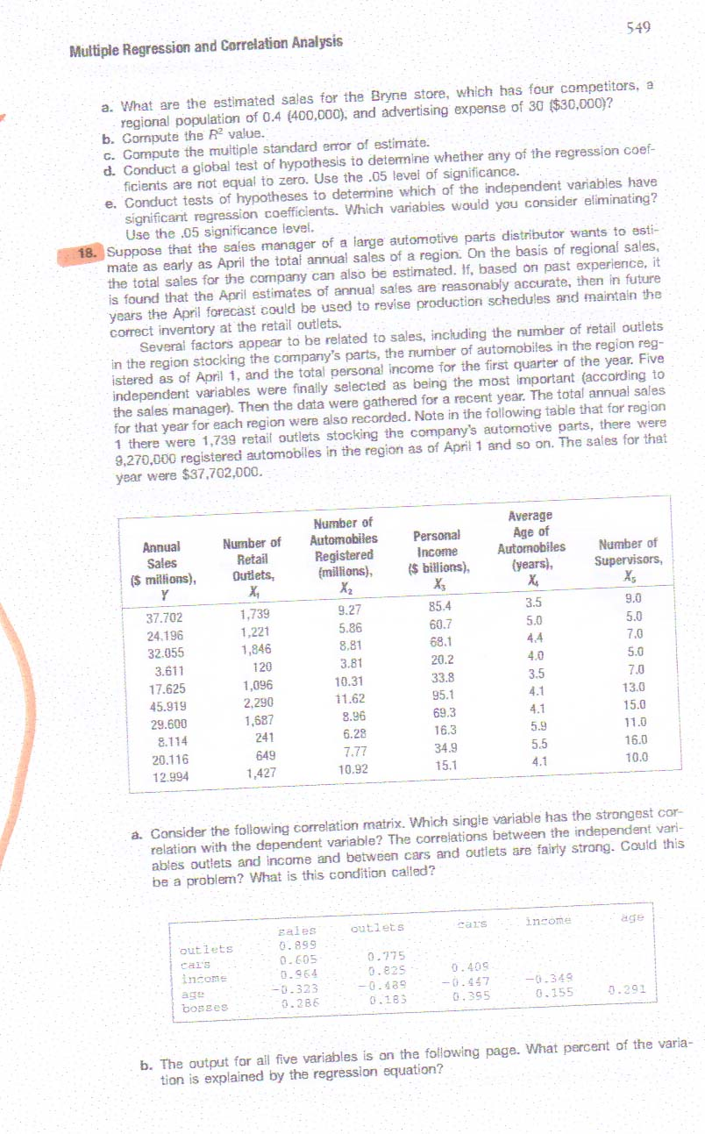
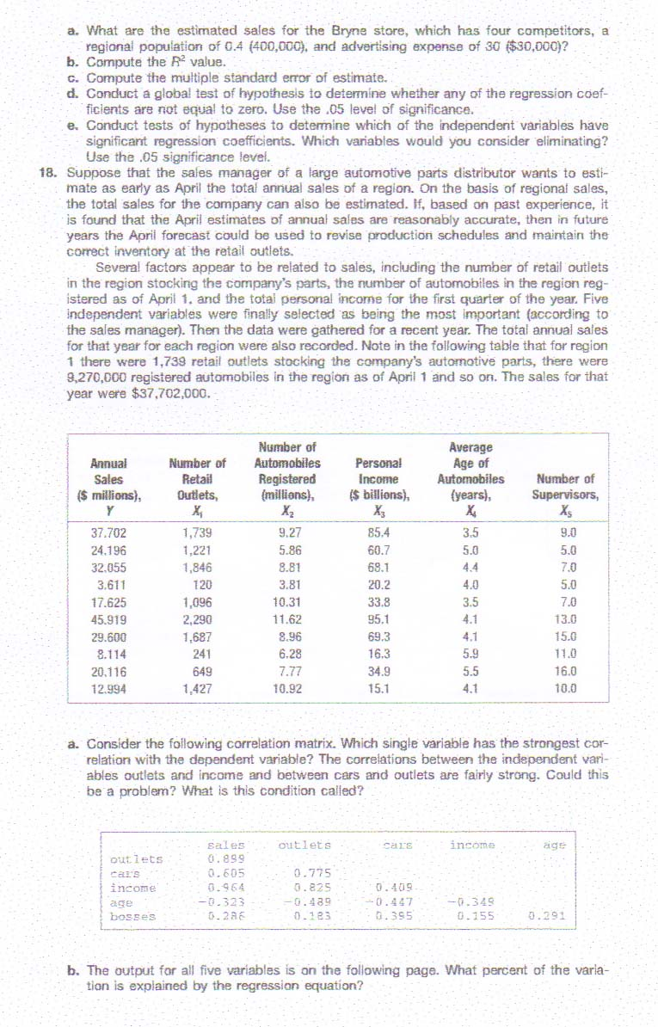

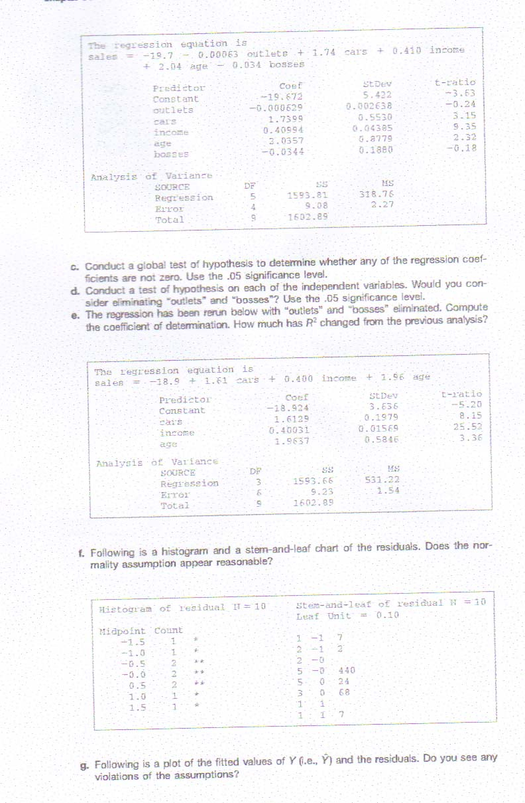
o Ch. 17, p. 664-65 – exercise 22
