Name:

MTH133

**Name:**

1) State the domain of the following and provide a brief explanation for your answer:

a) 

Answer:

b) 

Answer:

c) 

Answer:

d) 

Answer:

e) 

Answer:

2) Suppose the graph of is shifted to obtain each the following graphs. What is the equation of the function, *g*(*x*), for each graph? Write your answers in terms of x2 and/or x.

a)



Answer:

b)



Answer:

3) Consider the following graph of *y* = *f*(*x*).



*P*

a) If *h*(*x*) = *f*(*x*) – 3, what would the new coordinates of *P* be after the shift? Give answer in (*x, y*) form.

Answer:

b) If  what would the new coordinates of *P* be after the reflection? Give answer in (*x, y*) form.

Answer:

4) Consider the function.

a) Find *h*, the *x*-coordinate of the vertex of this parabola.

Answer:

Show your work here:

b) Substitute the two integers immediately to the left of *h* and the two integers immediately to the right of *h* into the function to find the corresponding *y* values. Fill in the table below. Make sure your *x*-values are in increasing order in your table.

|  |  |
| --- | --- |
| ***x*** | ***y*** |
|  |  |
|  |  |
| ***h*=__** |  |
|  |  |
|  |  |

c) Use MS Excel or another web-based graphing utility to graph the function by plotting the points found in the table in part b. Read the information in the assignments list to learn more about how to graph in MS Excel.

5) Find the equations for the horizontal and vertical asymptotes of the following. Type “none” if the function does not have an asymptote.

a) 

Horizontal:

Vertical:

b) 

Horizontal:

Vertical:

c)

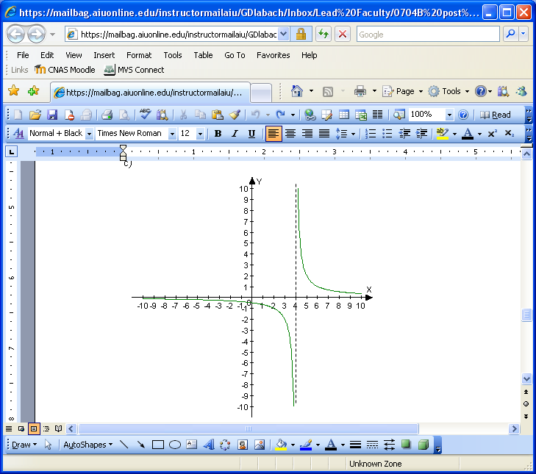

Horizontal:

Vertical:

d)

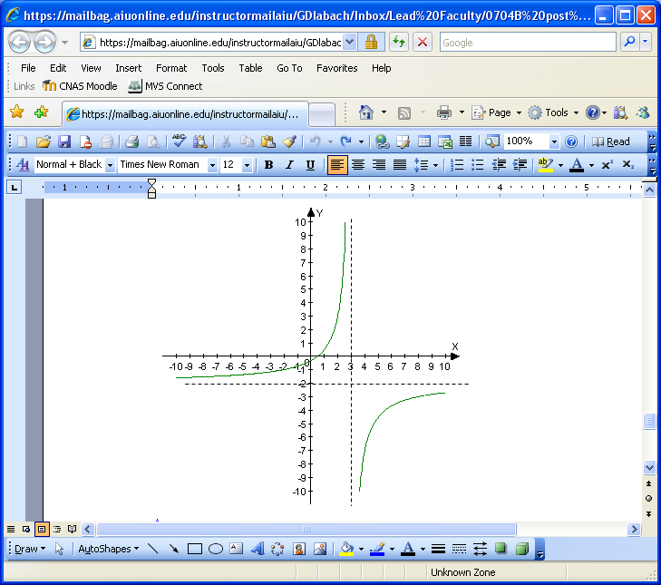

Horizontal:

Vertical