.
1. Factor completely.
25x² + 80x + 64
A) Prime
B) (5x + 8)²
C) (5x + 8)(5x - 8)
D) (5x - 8)²
2.
Factor completely.
15z² + 14z - 8
A) (15z + 4)(z - 2)
B) (3z - 4)(5z + 2)
C) Prime
D) (3z + 4)(5z - 2)
3.
Write the expression in lowest terms.
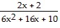
A)
B) 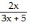
C) 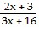
D) 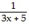
4.
Solve by the square-root property.
(x + 9)² - 3 = 0
A) 9 ±
B) -6, 12
C) -3 ±
D) -9 ±
5.
Factor completely.
x² + 50x + 625
A) (x - 25)²
B) Prime
C) (x + 25)(x - 25)
D) (x + 25)²

6. Evaluate the expression. Write answer without exponents.
-10⁰
A) 0
B) -10
C) 1
D) -1
7.
Perform the indicated operations. Give the answer in lowest terms.
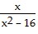- 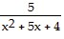
A) 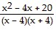
B) 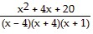
C) 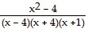
D) 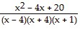

8.
Solve the equation.
+ 3 = 8
A) -25
B) -27
C) 25
D) 27

9.
Factor completely.
x² - 12xy + 36y²
A) (x - 6y)²
B) (x - 6y)(x + 6y)
C) Prime
D) (x + 6y)²

10.
Fill in the blank with either =, <, or > to make the statement true.
∙ ______
A) =
B) >
C) <
11.
Evaluate the expression using order of operations.
2 ∙ 5²
A) 100
B) 250
C) 10
D) 50
12.
Perform the indicated operations. Give the answer in lowest terms.
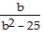+ 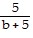-
A) 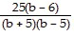
B) 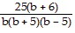
C) 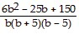
D) 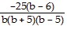

13.
Perform the indicated operation. Give the answer in lowest terms.
÷ 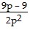
A)
B) 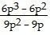
C) 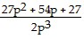
D)
14.
Simplify. Leave answer with exponent.
(5y)⁴ ∙ (5y)⁷
A) 25y¹¹
B) 25y²⁸
C) 5y²⁸
D) (5y)¹¹

15.
Use a calculator to evaluate the expression.
¹¹
A) 12.8333
B) 5.4502
C) 9.4286
D) 0.1835
16.
Find expressions for the Revenue, Cost, and Profit from selling x thousand items.
Item Price Fixed Cost Variable Cost
$7.00 $195,503 -3x² + 3480x - 100
A) R = 7000x; C = -3x² + 3480x + 195,403; P = 3x² - 2780x - 195,403
B) R = 7000x; C = -3x² + 3480x + 195,503; P = 3x² - 2780x - 195,403
C) R = 7000x; C = 3x² + 3480x + 195,403; P = -3x² - 2780x - 195,403
D) R = 7000x; C = -3x² + 3480x + 195,403; P = 3x² - 2780x - 195,503

17.
Write the rational exponent expression as an equivalent radical expression.
(-3x)^{-1/3}
A) 3
B) 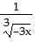
C) 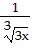
D)
18.
Factor out the greatest common factor.
4(x + 5)² + 3(x + 5)⁴
A) (x + 5)²(3x² + 30x + 79)
B) (x + 5)²(3x² + 79)
C) 7(x + 5)
D) 7(x + 5)²

19.
Simplify the expression.
A) 65
B)
C) 77
D)
20.
Find the product.
(4x + 6)(4x - 6)
A) 16x² - 36
B) 4x² - 48x - 36
C) 16x² + 48x - 36
D) 16x² - 48x - 36
21.
Name the property illustrated.
8(7 + 9) = (7 + 9)8
A) Commutative property
B) Associative and commutative properties
C) Distributive and associative properties
D) Identity and associative properties
22.
Mark the statement as true or false.
The absolute value of any nonzero number is positive.
A) True
B) False
23.
Rationalize the denominator. Assume all variables represent positive real numbers.
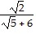
A) 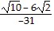
B) 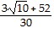
C) 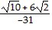
D) 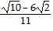

24.
Solve the equation.
=
A) 4
B) -12
C) -4
D) 3
25.
Perform the indicated operation. Give the answer in lowest terms.
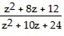÷ 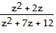
A) 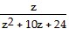
B) 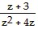
C) z + 3
D) 