Name: | Phase 4 Discussion Board
Deliverable Length: | 4-5 paragraphs
Details: | In addition to the six basic graphs, programmers and game designers also need a resource to help them understand, analyze, and graph rational functions that frequently come up in their game designs.  First, pick a rational function and graph it.  For example, y = 1/x is a rational function. The graph looks like the following:  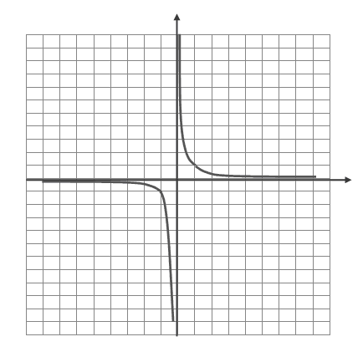  Select a different function for your example. Then discuss the following:  - Determine whether or not the graph crosses either the x or y axis and identify these points.  - Discover and identify the asymptotes of the graph.  When posting your response, upload the file that contains your graph to the Discussion Board.  In your own words, please post a response to the Discussion Board and comment on other postings. You will be graded on the quality of your postings.
Points Possible: | 50
Date Due: | Friday, Jun 19, 2009
Objective: | • Analyze and graph variations of six basic function graphs.
Submitted Files: | Discussion Board
Score: | N/A

