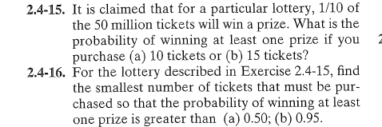

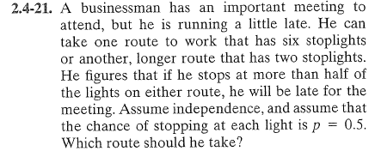

2.1-15 ans = a) .6513, b).7941

2.1-16 a) n=7, n=29

2.4-21 take longer route

