A block of wood floats on water. A layer of oil is now poured on top of the water to a depth that more than covers the block, as shown in Figure 15-30.
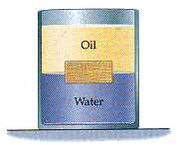
Figure 15-30
(a) Is the volume of wood submerged in water greater than, less than, or the same as before?

more wood submerged in water than before
less wood submerged in water than before
same amount of wood is submerged in water as before
(b) If 75% of the wood is submerged in water before the oil is added, find the fraction submerged when oil with a density of 731 kg/m³ covers the block. (Do not neglect the buoyant force of air before the oil is added.)
%

