The Jackson Company is considering the purchase of a new machine that is expected to reduce cash outflows. The cost of this machine is $29,000. The annual reduction in cash outflows is as follows:
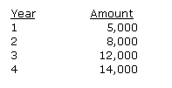
If the cost of capital is 10%, please calculate the following:
- A. The Present Value of the Benefits (PVB) - Show your work.
- B. The Present Value of the Costs (PVC)
- C. Net Present Value (NPV) (Show your work)
- D. Should we buy the machine based on your above analysis? Please explain

