The LJB Company contribution income statement for the most recent month is presented below:
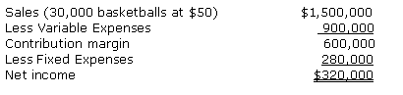
Compute the company's contribution margin percentage and break-even point in both units and dollars.

