The L-shaped object in Figure 11-27 consists of three masses connected by light rods.
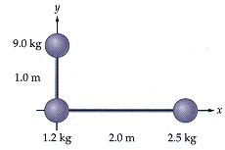
Figure 11-27
(a) What torque must be applied to this object to give it an angular acceleration of 1.27 rad/s² if it is rotated about the x axis?
_________N·m
(b) What torque must be applied to this object to give it an angular acceleration of 1.27 rad/s² if it is rotated about the y axis?
_________N·m
(c) What torque must be applied to this object to give it an angular acceleration of 1.27 rad/s² if it is rotated about the z axis (which is through the origin and perpendicular to the page)?
_________N·m

