Question 2
A hypothetical monopoly firm is characterized by the following diagram.

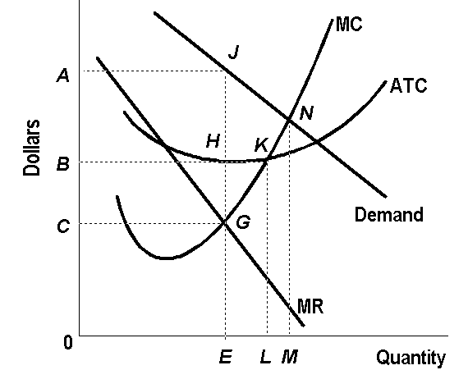

- Assuming that the above firm is a profit maximizer operating in the short run, determine its optimal price?
- Determine the firm’s profit per unit.
- What is the ATC in dollars?

- If the above monopolist were to behave like a perfectly competitive firm (operating in the long run), determine its price

(Please explain the reason behind your answer for each question above.)

