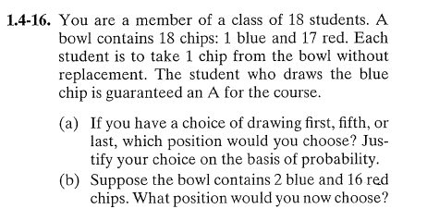

answer:

- It does not matter…P(B1)=P(B5)= P(B18)=1/18
- P(b)=2/18 on each draw

