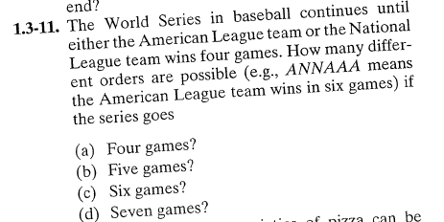

answers: a= 2

b=8

c=20

d=40

