Write SQL Queries (SELECT statements) using BETWEEN, LIKE, UNION, and GROUP.
Using the database and tables from Week Two, write SQL INSERT statements to insert records into the employee table for the workers identified in the Employee Files for the administrative offices and the Del Mar location. Check your results by selecting all of the columns from both of your tables

Using the database and tables in Week Two, write SQL queries using BETWEEN, LIKE, and UNION:
Write a SQL query that joins two tables in the example database and uses BETWEEN to restrict record selection. (Use Emp_salary to restrict the data.)
Write a SQL query that joins two tables in the example database and uses BETWEEN to restrict record selection. (Use Hire_date to restrict the data.)
Write a SQL query that joins two tables in the example database and uses LIKE to restrict record selection. (Use Telephone_area_code to restrict data.)
Write a SQL query that joins two tables in the example database and uses LIKE to restrict record selection. (Use Emp_age to restrict data.)
Write a SQL query that uses UNION of the two tables to produce a combined result set.

Using the updated database that includes employees from administrative offices and the Delmar location, write the following queries using the SQL GROUP BY statement:
Group employees by job classification: Select the employees’ last names and group them by EEO_1_classification.
Group employees by salary: Select the employees’ last names and group them by Emp_salary.
Group employees by salary within their job classification: Select the employees’ last names and group them by Emp_salary within their EEO_1_Classification.
Select the employees’ last names and group them by salary within job titles that are grouped into exempt and non-exempt.

In Microsoft SQL Server Management Studio, save your SQL statements as .SQL files. Save your SQL output as .RPT files. You will need to post both types of files (.SQL and .RPT).

Administrative offices

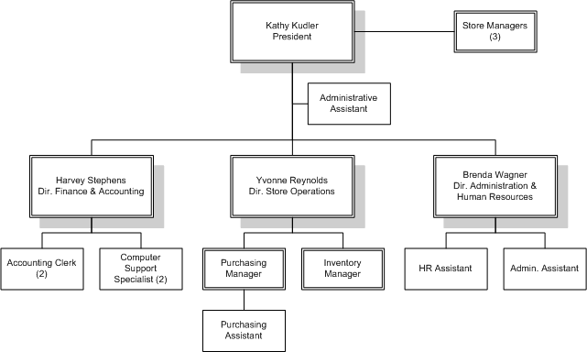

Del Mar

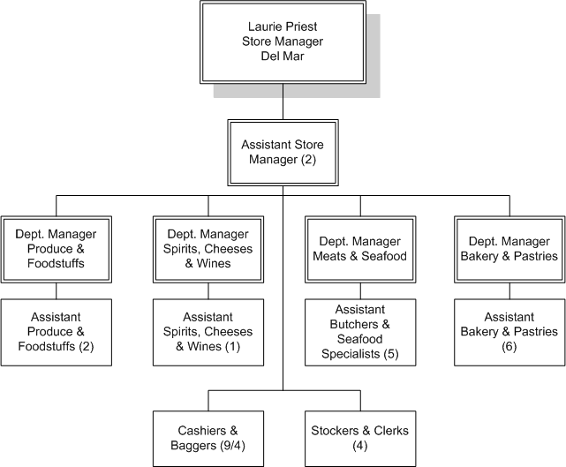

Administrative Employee Files
Position | EEO-1 Classification | Incumbent | Hire Date | Hourly Rate | Annualized Salary | Gender | Race | Age
President | Officials & Managers | Kathy Kudler | 1/1/1998 |  | $100,000.00 | F | Caucasian | 52
Dir. Of Fin & Acct. | Officials & Managers | Harvey Stephens | 3/1/1998 |  | $75,000.00 | M | Caucasian | 51
Accounting Clerk | Office/Clerical | Juanita McNamara | 10/29/1999 | $12.75 | $25,500.00 | F | Hispanic | 32
Bagger – 30 hours/wk | Office/Clerical | Phillip Pighetti | 4/27/2001 | $12.25 | $24,500.00 | M | Caucasian | 27
Computer Support Specialist | Technician | Meredith Nguyen | 9/27/1998 | $21.50 | $43,000.00 | M | Caucasian | 25
Computer Support Specialist | Technician | Matthew Vu | 8/16/2000 | $18.50 | $37,000.00 | M | Asian | 26
Dir. of Store Operations | Officials & Managers | Yvonne Reynolds | 4/1/1998 |  | $70,000.00 | F | African American | 42
Manager of Purchasing | Officials & Managers | Daniel Pitcher | 6/25/1999 |  | $50,000.00 | M | Caucasian | 35
Inventory Manager | Officials & Managers | Arlyn Rilley | 10/24/2001 |  | $45,000.00 | M | Caucasian | 32
Purchasing Assistant | Office/Clerical | Juanita Santiago | 12/29/2001 |  | $33,000.00 | F | Hispanic | 29
Dir. of Admin. & HR | Officials & Managers | Brenda Wagner | 4/1/1998 |  | $60,000.00 | F | African American | 44
HR Assistant | Professional | Cecilia Sams | 9/25/2001 |  | $35,000.00 | F | Caucasian | 31
Admin. Asst. | Office/Clerical | Arthur Stepka | 11/2/1999 | $16.50 | $33,000.00 | M | Caucasian | 29

Del Mar Employee Files
Position | EEO-1 Classification | Incumbent | Hire Date | Hourly Rate | Annualized Salary | Gender | Race | Age
Store Manager | Officials & Managers | Laurie Priest | 6/1/1998 |  | $67,000.00 | F | Caucasian | 34
Assistant Manager | Officials & Managers | Craig Drohos | 6/15/2000 |  | $51,000.00 | M | Caucasian | 32
Assistant Manager | Officials & Managers | Erin Thompson | 5/1/1999 |  | $47,367.00 | F | Caucasian | 28
Dept. Mgr. - Produce & Foodstuffs | Officials & Managers | Ernestina Vasquez | 7/22/2000 |  | $38,000.00 | F | Hispanic | 27
Dept. Mgr. - Spirits, Cheeses & Wines | Officials & Managers | Fouay Chumakov | 8/1/2002 |  | $40,000.00 | M | Asian | 26
Dept. Mgr. - Meats & Seafood | Officials & Managers | Maria Cantu | 3/2/2002 |  | $37,000.00 | F | Hispanic | 45
Dept. Mgr. - Bakery & Pastries | Officials & Managers | Randy Depree | 12/7/1999 |  | $34,000.00 | M | Caucasian | 40
Asst. - Produce & Foodstuffs | Sales Workers | Connie Garcia | 10/7/2001 | $9.75 | $19,500.00 | F | Hispanic | 36
Asst. - Produce & Foodstuffs | Sales Workers | Gregory Freeman | 8/30/2002 | $9.75 | $19,500.00 | M | African American | 31
Asst. - Spirits, Cheeses & Wines | Sales Workers | Cyndi Grewell | 5/14/2003 | $10.50 | $21,000.00 | F | Caucasian | 32
Asst. - Butchers & Seafood Specialists | Operatives (Semi skilled) | Clay Lomax | 11/27/2001 | $10.30 | $20,600.00 | M | Caucasian | 28
Asst. - Butchers & Seafood Specialists | Operatives (Semi skilled) | Fran Lopez-Palma | 3/28/2002 | $10.25 | $20,500.00 | F | Hispanic | 27
Asst. - Butchers & Seafood Specialists | Operatives (Semi skilled) | Aaron Nitkowski | 1/20/2002 | $10.75 | $21,500.00 | M | Caucasian | 32
Asst. - Butchers & Seafood Specialists | Operatives (Semi skilled) | Patrick Rayder | 3/11/2002 | $11.25 | $22,500.00 | M | Caucasian | 28
Asst. - Butchers & Seafood Specialists | Operatives (Semi skilled) | Stan Quillian | 12/16/1999 | $11.50 | $23,000.00 | M | American Indian | 29
Asst. - Bakery & Pastry | Craft Workers (Skilled) | Martha Quintero | 6/16/2003 | $9.75 | $19,500.00 | F | Hispanic | 26
Asst. - Bakery & Pastry | Craft Workers (Skilled) | Perry VanSlooten | 12/25/2002 | $9.75 | $19,500.00 | M | Caucasian | 24
Asst. - Bakery & Pastry | Craft Workers (Skilled) | Larissa Urtado | 2/5/2003 | $9.50 | $19,000.00 | F | Asian | 35
Asst. - Bakery & Pastry | Craft Workers (Skilled) | Thomas Tyink | 5/1/2001 | $9.50 | $19,000.00 | M | African American | 32
Asst. - Bakery & Pastry | Craft Workers (Skilled) | Ledonna Avery | 3/28/2003 | $10.50 | $21,000.00 | F | African American | 23
Asst. - Bakery & Pastry | Craft Workers (Skilled) | David Ball | 8/22/2000 | $10.25 | $20,500.00 | M | Caucasian | 26
Cashier | Sales Workers | Chris Bareman | 2/6/2002 | $9.50 | $19,000.00 | M | Caucasian | 24
Cashier | Sales Workers | George Bakker | 2/10/2003 | $9.25 | $18,500.00 | M | Caucasian | 19
Cashier | Sales Workers | Israel Bruss | 5/8/2001 | $9.50 | $19,000.00 | M | African American | 22
Cashier | Sales Workers | Mark Grayson | 4/16/2003 | $9.00 | $18,000.00 | M | Caucasian | 21
Cashier | Sales Workers | Phanthousit Soukhone | 11/29/2002 | $10.25 | $20,500.00 | M | Asian | 42
Cashier | Sales Workers | Angie Merz | 8/26/2000 | $9.00 | $18,000.00 | F | Hispanic | 38
Cashier | Sales Workers | Margarita Lopez | 12/27/2001 | $10.00 | $20,000.00 | F | Hispanic | 52
Cashier | Sales Workers | Elaine Meier | 9/10/2000 | $10.25 | $20,500.00 | F | Asian | 51
Cashier | Sales Workers | Derea Spencer | 4/11/2003 | $9.75 | $19,500.00 | M | African American | 44
Bagger | Sales Workers | Linzee Sobota | 6/9/2002 | $7.00 | $14,000.00 | F | Hispanic | 21
Bagger | Sales Workers | Ken Soper | 4/16/2003 | $7.25 | $14,500.00 | M | African American | 32
Bagger - 30 hours/wk | Sales Workers | Gregg Sobkowiak | 12/17/2001 | $7.00 | $10,920.00 | M | Caucasian | 21
Bagger - 30 hours/wk | Sales Workers | Brent Vance | 3/29/2001 | $6.75 | $10,530.00 | M | Caucasian | 22
Stocker | Office/Clerical | Art Miller | 9/29/2003 | $7.50 | $15,000.00 | M | African American | 19
Stocker | Office/Clerical | Luis Munoz | 3/31/2001 | $7.25 | $14,500.00 | M | Hispanic | 22
Clerk | Office/Clerical | Eden Chapman | 9/13/2001 | $8.75 | $17,500.00 | F | Caucasian | 23
Clerk | Office/Clerical | Jose Chavez | 11/19/2003 | $8.25 | $16,500.00 | M | Hispanic | 19

