A = P (1 + R/N) NT

$12,000 is invested in an account paying 6% annual interest, compounded quarterly.
Find the amount of money in the account at the end of 10 years.
(Show values substituted in the formula, and calculate the numerical amount.)

For each graph, does it represent a one-to-one function? (Yes or No?)Please explain one example of what I should look for to understand.

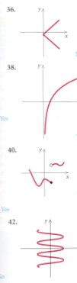
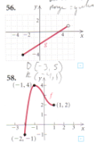
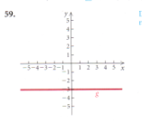

sketch the graph of the function. Describe how each graph can be obtain from the graph of a basic exponential function
f(x) = 2 ^x – 1

f(x) = 2^x + 1

Solve
1
x - 3 ≤ 0

solve. showing the check of potential solutions. (please correct my work and show the check)
x - 12/x = 1 LCD = x
x^2 - 12 = x
x^2 - x - 12 = 0
x^2 + 3x - 4x - 12 = 0
x(x + 3) -4(x + 3) = 0
(x - 4)(x + 3) = 0
x - 4 = 0
x + 3 = 0
x^1 = 4
x^2 = -3

Two wine merchants enter Paris, one of them with 64 casks of wine, the other with 20. Since they have not enough money to pay the custom duties, the first pays 5 casks of wine and 40 francs, and the second pays 2 casks of wine and receives 40 francs in change. What is the price of each cask of wine and the duty on it?

