The parametric equations of a curve are:
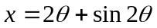 y = 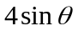

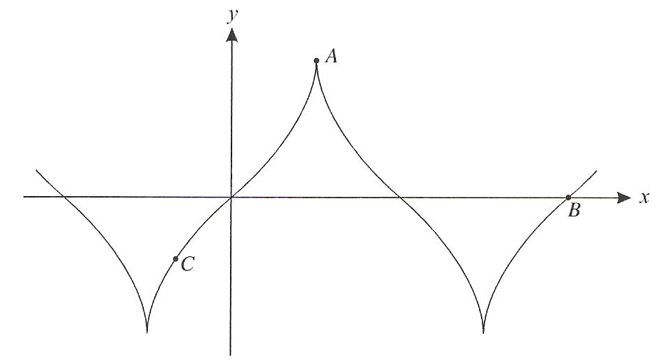

Find the value of at A and the value of at B.

