|  |  |  |  |  |  |
| --- | --- | --- | --- | --- | --- |
| |  |  |  |  |  | | --- | --- | --- | --- | --- | | |  |  |  | | --- | --- | --- | | |  |  | | --- | --- | | |  | | --- | | **Selecting a distribution for inferences on the population mean**  Suppose that we want to estimate the mean cholesterol level in adults aged http://www.phoenix.aleks.com/alekscgi/x/math2htgif.exe/M?66or more. We choose a random sample of such levels. The random sample we choose has a mean of http://www.phoenix.aleks.com/alekscgi/x/math2htgif.exe/M?2%3A5%2D6mg/dL and a standard deviation of http://www.phoenix.aleks.com/alekscgi/x/math2htgif.exe/M?2%3B%2D6mg/dL. For each of the following sampling scenarios, determine which test statistic is appropriate to use when making inference statements about the [population mean](http://www.phoenix.aleks.com/alekscgi/x/Isl.exe/1_6Ubx-HrxgwrQw0-LW2m8A917ZD8rN9dVU3yipEWTLollaVwkPkwicW8WfZF0hayvVFvqFyZgL0jYYEME0TWDA3MiBYQ0GBPu_LMSq8hTTiTPlJcUzD?12qVSkxkWihcIGUrcD-dx9kNQRw8r4N44cPWE9JBapjXhBpPzsnIxXNMwcrLwWxkHEWxTL88jVn7mZ4ny5rKnzSg0PfusdvI-FLGY54IiltSDt1hrro).  (In the table, http://www.phoenix.aleks.com/alekscgi/x/math2htgif.exe/M?Yrefers to a variable having a [standard normal distribution](http://www.phoenix.aleks.com/alekscgi/x/Isl.exe/1rwcMMoJXMtSX6fOTabkv9K1euOTtPh1WWQp624GzHBmgJggZO9oZ2nxtYEh3C4A6KIWjIju50BO-9PG2wylzF5p2guMGCeRBLW22OsUHH_v7l8fdEMs?1YnAICIXBWSge0gfoajXR361XId-VmUyR-FcawoSp3QTVP-a2Qw96gonpgyeKSjUdi0wujwDMrNJM2q7SWG3jDhim0Ax07ejUqNVgFvm_5aMQM92vTp9GqD2IQH8BeXr7eo), and http://www.phoenix.aleks.com/alekscgi/x/math2htgif.exe/M?wrefers to a variable having a [*t* distribution](http://www.phoenix.aleks.com/alekscgi/x/Isl.exe/1OhwKs8h6sF26XqAgKaCLymzT5reFdxuin3noYuA1ZfIchcTH10dHYpHFms398zzoMLn4c45uHfAl3R0Stes1qmFSYEsb8TifQitSAML0ZtxU-CixuKD?1vWFTttAt5P1XuckVSbACXo5RZQKqxg37jFs3gqyKMqG2djU3iViMvwqt4NqSXq49HXtBJBB6AAFiTEcfbtCxC4GTrmjU-TfuDUqf-VfLQCgAudIH).) | | | |  | |

|  |
| --- |
|  |

|  |
| --- |
|  |

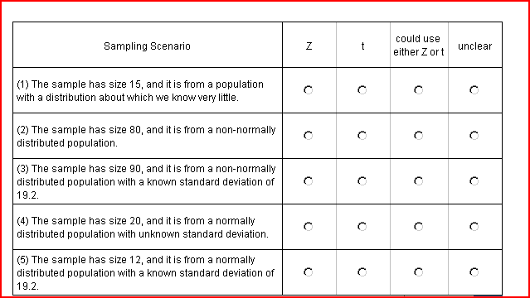

**Check correct boxes**