1.
To find the mass of a thin-shelled ellipsoid, you have to:
A) Determine the inside surface area and then multiply by the shell’s thickness
B) Determine the average of the inside and outside surface areas and then multiply by the shell’s thickness
C) Find the difference of the outer volume and the inner (vacuous) volume
D) None of the above
2.
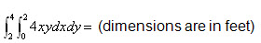
A) 80 ft³
B) 4 ft³
C) 48 ft³
D) You cannot evaluate this because you have to integrate first with respect y then with respect to x
3.
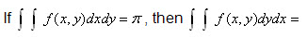
A)
B)
C) 0
D) There is no way to know unless f(x, y) is defined
4.
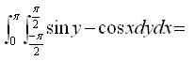
A)
B)
C) 0
D) 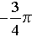
5.
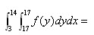
A) No solution
B) 11
C) 0
D) You have to know what f(y) is first
6.
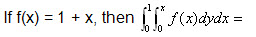
A) 5/6
B) 2/3
C) ½
D) Undefined; you cannot integrate f(x) with respect to y
7.
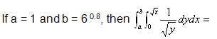
A) 9.6
B) 3.2
C) 8.0
D) No solution
8.
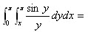
A)
B) 2
C) e ^{–x} sin(x)
D)
9.
Determine the volume of the solid bounded by the parabolic cylinders z = x², z = 2x², y = x², and y = 8 – x².
A) 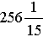
B) 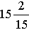
C)
D) 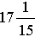
10.
Which of the following is not a property of double integrals?
A) 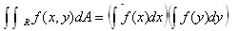
B) 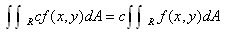
C)
D) 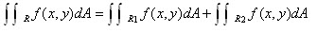
11.
What is the conversion for dA when going from rectangular to spherical coordinates?
A) dA = r dr d
B) dA = r sin
C) dA = sinø
D) None of the above
12.
A)
B)
C)
D) 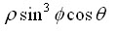
13.
What is it that cylindrical coordinate integrals have that columnar rectangular coordinate integrals do not have?
A) z
B) ø
C) sinø
D) z sinø
14.
What are the spherical coordinates of the centroid of a hollow sphere with wall thickness = δ, outer radius = α, and inner radius = β?
A) (0, 0, 0.75 δ)
B) (1, 0,π δ )
C) (0, 0, 0.375 δ )
D) (0.5 α , 0.5 β, 0.5 δ)

15.
What’s the relationship between vector fields and gradient vectors?
A) Gradient vectors are a subset of vector fields
B) Vector fields are a subset of gradient vectors
C) Gradients are a derivative of vector fields
D) Gradient vectors + line integrals = vector fields

16.
Determine div F for F(x, y, z) = xi + yj + zk

A) √3
B) 1
C) 3
D) None of the above
17.
Determine div F for F(x, y, z) = (y² + z²)i + (x² + z²)j + (y² + x²)k

A) 2x – 2y – 2z
B) √2
C) √8
D) none of the above
18.
What is the conversion from the parametric form of a line integral to arc length as the variable on integration?
A) 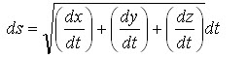
B) 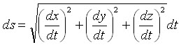
C)
D)
19.
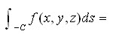
A) 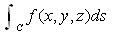
B) 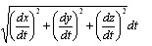
C) 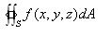
D) 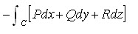
20.
A) 0.30
B) 0.71
C)
D)

