Individual Assignment: Exponential and Reciprocal Functions

A. Marshall, McManus, & Viele (Text F)
Ch 6, problem P6-26 a.. b. c and d only (Page 224)

P6-26 Present value calculations. Using a present value table, your calculator, or a computer program present value function, answer the following questions:

Required:
a. What is the present value of nine annual cash payments of $4,000, to be paid at the end of each year using an interest rate of 6%?

b. What is the present value of $15,000 to be paid at the end of 20 years, using an interest rate of 18%?

c. How much cash must be deposited in a savings account as a single amount in order to accumulate $300,000 at the end of 12 years, assuming that the account will earn 10% interest and the interest is reinvested?

d. How much cash must be deposited in a savings account (as a single amount)
in order to accumulate $50,000 at the end of seven years, assuming that the
account will earn 12% interest and the interest is reinvested”

B. Sevilla & Somers text (text G)

Topic 6, exploration 8b (Page 118) and c (added by me)

Consider the formula P = 67.38 * (1.026)^{t} . If we let P represent the population of Mexico in year t where t is the number of years from 1980, confirm that this formula gives the same population values as those given in the table in
Example 6.5.

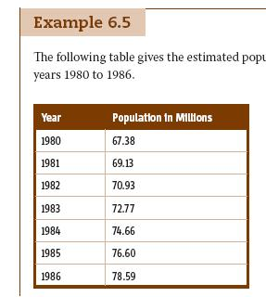

b, What would the population in 1990 have been if growth had continued in
this same pattern?

c. How many years beyond 1980 will it take to double the population assuming the
growth continues in the same pattern?

The effect of inflation (added)
- What is the future value of saving $3000 per year at 10% per year interest, for 20 years, assuming reinvestment of interest at the same rate.

- Assume inflation is a constant 4% per year. What effect does that have on the “real” eventual amount?

- If inflation continues at 4% per year what will the “real value” of a dollar be in 20 years?

- If inflation is 10% per year what will the “real value” of a dollar be in 20 years.

