1.
Let a = 2i + 3j and b = -9i + 6j. Find c = a – b.
A) c = -3j
B) c = 9i
C) c = 11i + 9j
D) c = 11i – 3j
2.
Let a = 2i + 3j and b = -9i + 6j. Find d = a • b.
A) 36
B) -36
C) 0
D) -18i² + 18j²
3.
Find the intersection of L₁: x – 2 = ½(y + 1) = 1/3(z – 3), L₂: 1/3(x – 5) = ½(y – 1) = z – 4, if they intersect.
A) (-1, 2, -3)
B) (0, 0, 3)
C) (2, -1, 3)
D) They do not intersect
4.
What can we say about the plane with n = (7, 11, 0)?
A) It’s perpendicular to the x-y plane
B) It’s the x-y plane
C) It’s parallel to the x-y plane, but offset by units along the z-axis
D) It’s parallel to the x-y plane, but offset by units along the z-axis
5.
What can we say about L: x = 7 – 4t, y = 3 + 6t, z = 9 + 5t and P: 4x + y + 2z = 17?
A) They are orthogonal
B) L is co-planer with P
C) L and P are parallel
D) L intersects P at a angle relative to the z-axis

6.
Convert the following into spherical coordinates: x² + y² + z² = 36
A) radians
B) (6, 0.6, )
C) = 6
D) None of the above
7.
What is the angle between these two planes: x + 2y – z = 13 & -2x – 4y + 2z = -13?
A)
B)
C)
D)

8.
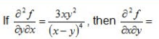
A) 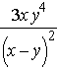
B) 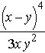
C) 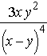
D) There is no way to know without knowing f(x,y) first
9.
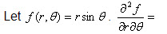
A) r
B)
C)
D)
10.
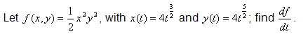
A) 384 t ⁷
B) 8 t ⁸
C) 1024 t ⁷
D) 64 t ⁵
11.
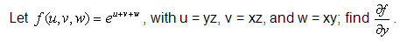
A) (x + z) exp(yz + xz + xy)
B) (x + z) exp(-yz - xz - xy)
C) (x + z) exp[y(x + z)]
D) exp(yz + xz + xy)
12.
A) 0
B) Cannot be differentiated
C) 108w²
D) None of the above
13.
There are two extrema for z = 2x – x² + 2y² – y⁴. One is located at (1, 1, 2). Where is the second one located?
A) (-1, 1, 2)
B) (1, -1, 2)
C) (1, 2, -1)
D) There is no second extreme point
14.
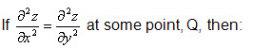
A) Q defines a minimum
B) Q defines a maximum
C) Q defines a minimum or a maximum
D) None of the above
15.
denotes:
A) The full derivative of f
B) For all f
C) A partial derivative of f with respect to some variable
D) The gradient vector of f
16.
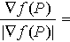
A)
B)
C)
D)

