Assignment 12

{Exercise 15.01}
The estimated regression equation for a model involving two independent variables and 10 observations follows.
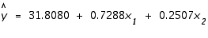
- Interpret b₁ and b₂ in this estimated regression equation.
b₁
b₂
- Estimate y when x₁ = 180 and x₂ = 310 (to 3 decimals).
{Exercise 15.05}
Use computer software packages, such as Minitab or Excel, to solve this problem.
The owner of Showtime Movie Theaters, Inc., would like to estimate weekly gross revenue as a function of advertising expenditures. Historical data for a sample of eight weeks follow.
Weekly | Television | Newspaper
Gross Revenue | Advertising | Advertising
($1,000s) | ($1,000s) | ($1,000s)
97 | 5.0 | 1.5
90 | 2.0 | 2.0
95 | 4.0 | 1.5
92 | 2.5 | 2.5
99 | 3.0 | 3.3
94 | 3.5 | 2.3
94 | 2.5 | 4.2
93 | 3.0 | 2.5
- Develop an estimated regression equation with the amount of television advertising as the independent variable (to 1 decimal).
Revenue = + TVAdv
- Develop an estimated regression equation with both television advertising and newspaper advertising as the independent variables (to 2 decimals).
Revenue = + TVAdv + NewsAdv
- Is the estimated regression equation coefficient for television advertising expenditures the same in part (a) and in part (b)?
- What is the estimate of the weekly gross revenue for a week when $3.6 thousand is spent on television advertising and $1.6 thousand is spent on newspaper advertising (in thousands, to 2 decimals)?
Exercise 15.11}
Consider the following estimated regression equation, based on 10 observations.
The values of SST and SSR are 6724.125 and 6216.375, respectively.
- Find SSE (to 2 decimals).
- Compute R² (to 3 decimals).
- Compute R²_{a} (to 3 decimals).
- How good is the fit provided by the estimated regression equation?
{Exercise 15.15}
The owner of Showtime Movie Theaters, Inc., used multiple regression analysis to predict gross revenue (y) as a function of television advertising (x₁) and newspaper advertising (x₂). The estimated regression equation was
The computer solution provided SST = 25.5 and SSR = 23.435.
- Compute R² and R²_{a} (to 3 decimals).
R²
R²_{a}

- When television advertising was the only independent variable, R² = .653 and R²_{a} = .595. Are the multiple regression analysis results preferable?
{Exercise 15.21}
The following estimated regression equation was developed for a model involving two independent variables.
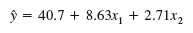
After x₂ was dropped from the model, the least squares method was used to obtain an estimated regression equation involving only x₁ as an independent variable.
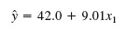
- In the two independent variable case, the coefficient x₁ represents the expected change in corresponding to a one unit increase in when is held constant.
In the single independent variable case, the coefficient x₁ represents the expected change in corresponding to a one unit increase in .
- Could multicollinearity explain why the coefficient of x₁ differs in the two models? Assume that x1 and x2 are correlated.
{Exercise 15.23}
The owner of Showtime Movie Theaters, Inc., would like to estimate weekly gross revenue as a function of advertising expenditures. Historical data for a sample of eight weeks follow.
Excel or Minitab users: The data set is available in file named Showtime. All data sets can be found in your eBook or on your Student CD.
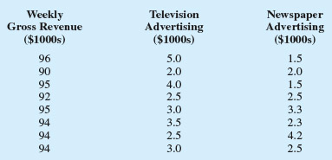
- Use = .01 to test the hypotheses
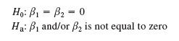
for the model y = ₀ + ₁x₁ + ₂x₂ + , where
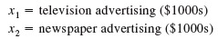
Compute the F test statistic (to 2 decimals).
What is the p-value?
What is your conclusion?
- Use = .05 to test the significance of ₁. Compute the t test statistic (to 2 decimals).
What is the p-value?
What is your conclusion?
Should x₁ be dropped from the model?
- Use = .05 to test the significance of ₂. Compute the t test statistic (to 2 decimals).
What is the p-value?
What is your conclusion?
Should x₂ be dropped from the model?
{Exercise 15.25}
Barron's conducts an annual review of online brokers, including both brokers that can be accessed via a Web browser, as well as direct-access brokers that connect customers directly with the broker's network server. Each broker's offerings and performance are evaluated in six areas, using a point value of 0-5 in each category. The results are weighted to obtain an overall score, and a final star rating, ranging from zero to five stars, is assigned to each broker. Trade execution, ease of use, and range of offerings are three of the areas evaluated. A point value of 5 in the trade execution area means the order entry and execution process flowed easily from one step to the next. A value of 5 in the ease of use area means that the site was easy to use and can be tailored to show what the user wants to see. Avalue of 5 in the range offerings area means that all of the investment transactions can be executed online. The following data show the point values for trade execution, ease of use, range of offerings, and the star rating for a sample of 10 of the online brokers that Barron's evaluated (Barron's, March 10, 2003).
Excel or Minitab users: The data set is available in file named Brokers. All data sets can be found in your eBook or on your Student CD.
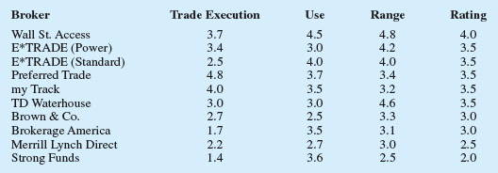
- Determine the estimated regression equation that can be used to predict the star rating given the point values for execution, ease of use, and range of offerings (to 3 decimals).
Rating = + TradeEx + Use + Range
- Use the F test to determine the overall significance of the relationship.
Compute the F test statistic (to 2 decimals).
What is the p-value?
What is your conclusion, using = .05?
- Use the t test to determine the significance of each independent variable. What is your conclusion at the .05 level of significance?
TradeEx
Use
Range

- Calculate the coefficient of determination for the equation in part (a) (to 3 decimals). Report R² between 0 and 1.
Remove any independent variable that is not significant from the estimated regression equation. Now, calculate the coefficient of determination (to 3 decimals). Report R² between 0 and 1.
Describe the difference in the fit provided by the two estimated regression equations.
- What is your recommended estimated regression equation (to 3 decimals)?
Rating = + +
{Exercise 15.37}
The National Football League rates prospects by position on a scale that ranges from 5 to 9. The ratings are interpreted as follows: 8-9 should start the first year; 7.0-7.9 should start; 6.0-6.9 will make the team as backup; and 5.0-5.9 can make the club and contribute. The following table shows the position, weight, time in seconds to run 40 yards, and ratings for 25 NFL prospects (USA Today, April 14, 2000).
Excel or Minitab users: The data set is available in file named Football. All data sets can be found in your eBook or on your Student CD.
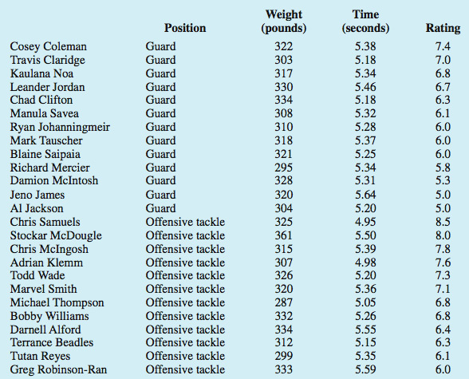
- Develop a dummy variable that will account for the player's position.
- Develop an estimated regression equation to show how rating is related to position, weight, and time to run 40 yards (to 4 decimals if necessary).
Rating = + Position + Weight + Time
At the .05 level of significance, test whether the estimated regression equation developed in part (b) indicates a significant relationship between the independent variables and the dependent variable.
Calculate the F test statistic (to 2 decimals).
What is the p-value?
What is your conclusion?
- Does the estimated regression equation provide a good fit for the observed data?
- Is position a significant factor in the player's rating? Use = .05.
- Suppose a new offensive tackle prospect who weighs 300 pounds ran the 40 yards in 5.1 seconds. Use the estimated regression equation developed in part (b) to estimate the rating for this player (to 2 decimals).

