Study Appendix 3. Richard Ellis, the director of cost operations of American Micro devices, wishes to develop an accurate cost function to explain and predict support costs in the company’s printed circuit board assembly operation.

Mr. Ellis is concerned that the cost function that he currently uses— based on direct labor costs—is not accurate enough for proper planning and control of support costs.

Mr. Ellis directed one of his financial analysts to obtain a random sample of 25 weeks of support costs and three possible cost drivers in the circuit-board assembly department: direct labor hours, number of boards assembled, and average cycle time of boards assembled. (Average cycle time is the average time between start and certified completion—after quality testing—of boards assembled during a week.)

Much of the effort in this assembly operation is devoted to testing for quality and reworking defective boards, all of which increase the average cycle time in any period. Therefore, Mr. Ellis believes that average cycle time will be the best support cost driver. Mr. Ellis wants his analyst to use regression analysis to demonstrate which cost driver best explains support costs.

Data is:

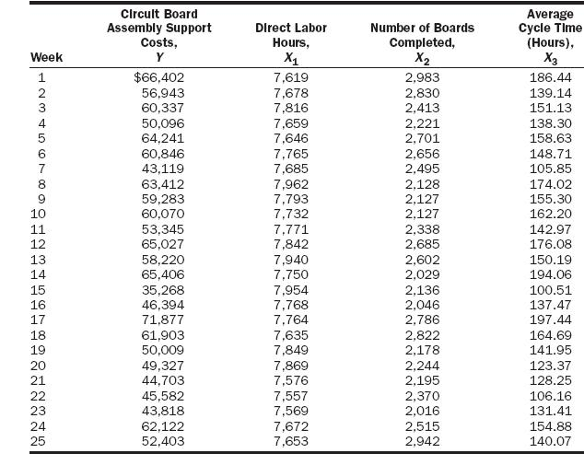

1. Plot support costs, Y, versus batch size, X.
2. Using regression analysis, measure the cost function of support costs and batch
size (number of boards). .
3. Predict the support costs for a batch size of 2500 boards .
4. Using the high-low method, repeat requirements 2 and 3. Should the manager use
the high-low or regression method? Explain.

