EXERCISE 9–7 Cash Budget Analysis [LO8]
A cash budget, by quarters, is given below for a retail company (000 omitted). The company requires a minimum cash balance of $5,000 to start each quarter. | (K)
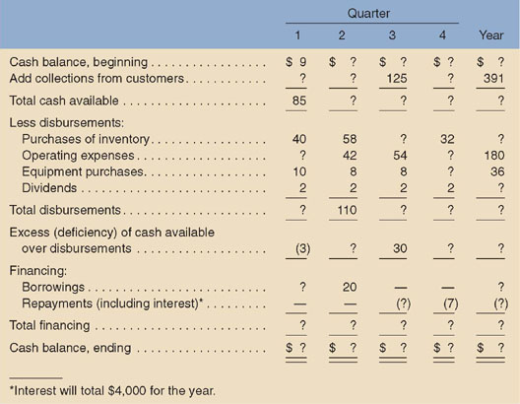(K)
Required:
Fill in the missing amounts in the table above

