1. What effect will the following entry have on Retained Earnings?
A) Retained Earnings will increase by $9,150.
B) Retained Earnings will decrease by $9,150.
C) Retained Earnings will remain unchanged.
D) Retained Earnings will be transferred to the income statement.
2.
On January 1, 2007, Shaffer Co. purchased inventory for $1,000 cash. These goods were sold on April 30, 2007 for $1,400 cash. The company can currently earn 3% interest on an account at a bank. What was Shaffer's cost of financing this inventory?
A) $10
B) $0
C) $30
D) $400
3.
Sine Company borrowed $20,000 on October 1, 2007 when the company issued a one-year note with a 6% annual interest rate. The adjusting entry necessary to record accrued interest on December 31, 2007 would include a:
A) debit to Interest Expense for $1,200.
B) debit to Interest Payable for $1,200.
C) debit to Notes Payable for $300.
D) debit to Interest Expense for $300.
4.
George Co. had beginning inventory of $400 and ending inventory of $200. The cost of goods sold was $1,600. Based on this information, George Co. must have purchased inventory amounting to:
A) $1,400.
B) $1,600.
C) $1,800.
D) $2,200.

5.
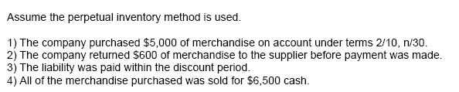
What effect will the return of merchandise to the supplier have on the accounting equation?
A) Assets and equity are reduced by $600.
B) Assets and liabilities are reduced by $570.
C) Assets and liabilities are reduced by $600.
D) Liabilities and equity are reduced by $600.
6.
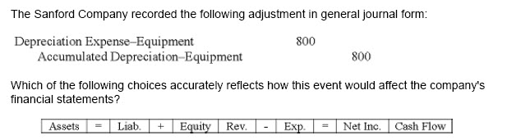
A)
B)
C)
D)
7.
Flint Company purchased $4,000 of merchandise on account. Flint sold the merchandise to a customer for $7,000 cash. What is the increase in gross margin and the net change in cash flow from operating activities as a result of these transactions?
A)
B)
C)
D)
8.
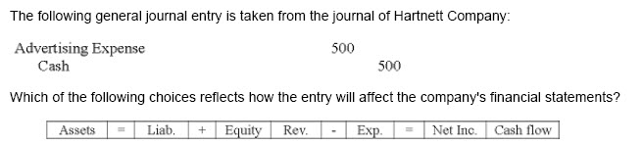
A)
B)
C)
D)
9.
Fosnough Company prepared a trial balance at December 31, 200Q: A trial balance that balances:
A) proves that all transactions have been properly recorded.
B) proves the equality of debits and credits.
C) can only be achieved after adjusting entries have been recorded.
D) none of these
10.
The left side of a T-account is known as the:
A) Equity side
B) Claims side
C) Debit side
D) Credit side
11.
On January 1, 2007, Corinth Company purchased one item of inventory for $12,000 cash. On June 30, 2007, Corinth sold the item for $19,000. If Corinth could presently earn 4% in its bank account, what is the cost of financing this inventory item?
A) No cost because the company used its own cash.
B) $380
C) $240
D) $140

12.
On November 1, 2007, Schumacher Company paid $1,200 in advance for an insurance policy that covered the company for six months. Assuming that Schumacher recorded this purchase as an asset, the adjusting entry required on December 31, 2007 would include:
A) a debit to Prepaid Insurance for $1,200.
B) a credit to Prepaid Insurance for $1,200.
C) a credit to Insurance Expense for $400.
D) a debit to Insurance Expense for $400.
13.
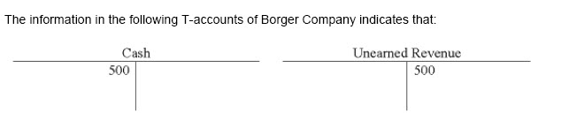
A) Cash has been paid out to a company that will provide future services to Borger Company.
B) Cash has been received by Borger and a liability account has been increased.
C) Borger has provided services to a customer and the cash account has been increased.
D) None of these
14.
Smith Company recorded the purchase of office equipment on account. Which of the following is the correct journal entry?
A)
B) 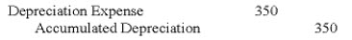
C) 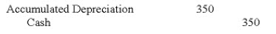
D)

15.
The Green Company uses the perpetual inventory system. Although its inventory records indicated $18,000 in the inventory, a physical count showed only $16,250. Which of the following indicates the effect of the necessary write-down entry?
A)
B)
C)
D)
16.
The part of the annual report that describes past performance and future plans in narrative form is called:
A) management discussion & analysis
B) footnotes to the financial statements
C) auditor's report
D) income statement
17.
The term "FOB Shipping Point" means:
A) The seller's responsibility ends at the destination.
B) The seller pays the shipping cost.
C) The buyer pays the shipping cost.
D) The buyer does not assume ownership until the goods are received.
18.
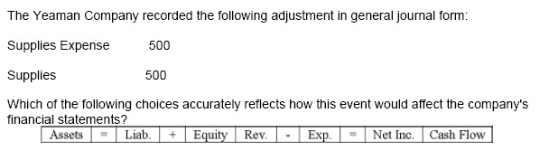
A)
B)
C)
D)

19.
Under a periodic system, the account debited for shipping costs on goods received from the vendor is called:
A) Merchandise Inventory
B) Cost of Goods Sold
C) Transportation-in
D) Transportation-out
20.
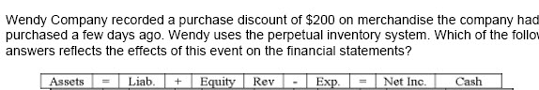
A)
B)
C)
D)
21.
What transaction does the following general journal entry represent?
Cash | 700
Accounts Receivable | 700

A) Provided services on account.
B) Paid cash owed to a supplier.
C) Collected cash from customers.
D) Borrowed money to support operating activities.
22.
Which is one effect of the following journal entry?
Unearned Revenue | 600
Consulting Revenue | 600

A) increases liabilities
B) increases revenue
C) decreases assets
D) increases assets
23.
Which of the following is increased with a debit?
A) Consulting Revenue
B) Depreciation Expense
C) Notes Payable
D) Common Stock
24.
Which of the following is considered a product cost?
A) Utility expense for the current month.
B) Transportation cost on goods received from suppliers.
C) Salaries paid to employees of a retailer.
D) Transportation cost on goods shipped to customers.
25.
Which of the following statements is true about period costs?
A) Operating expenses are not period costs.
B) Period costs are expensed when the products associated with these costs are sold.
C) Period costs are usually recorded as assets.
D) Most period costs are expensed in the period the costs are incurred.

