Introduction
The hydrolysis of aspirin is an extremely important reaction for mankind. Each time an aspirin tablet is taken for a headache, fever, or any other ailment, the hydrolysis of aspirin (acetylsalicylic acid) takes place in the stomach and the blood. Aspirin is hydrolyzed into two compounds, salicylic acid and acetate. Salicylic acid is the compound from this reaction that has biological activity. This process may also occur slowly in a bottle, releasing the smell of vinegar when the bottle is opened.
This experiment measures the kinetics of the base-catalyzed hydrolysis of aspirin using the Cary 50 UV/vis spectrophotometer. As the hydrolysis of aspirin proceeds, the salicylate ion is produced. The Cary 50 is used to measure the absorbance of the salicylate ion at 298 nm of light. The increasing absorbance of salicylate indicates that the base-catalyzed hydrolysis is proceeding. The absorbance can then be used to calculate the rate constant for the hydrolysis of aspirin.
Also, semi-empirical quantum chemical calculations on important structures in the hydrolysis reaction were performed. The semi-empirical methods gave approximate solutions to approximations of the Schrödinger equation. These approximations are not totally accurate; however, they are generally quick calculations that can show trends in a series of molecules. These calculations are used in this experiment to help the student get a sense as to how such calculations are carried out and they show how the bond lengths in the acetyl group change during the base-catalyzed hydrolysis of aspirin.

Experimental and Analysis
On average, one aspirin tablet contains about 325 mg of aspirin. One aspirin tablet was dissolved in 7 mL of ethanol. The tablet did not completely dissolve. This is thought to be due to impurities in the tablet that hold it together. Then, 0.1 mL of this solution was diluted with ethanol to make 5 mL and saved for a later step in the experiment.
Because the base-catalyzed hydrolysis produces acetic acid, a buffer solution was made to prevent the pH of the reaction solution from changing. If the pH is too low, then the reaction would not proceed through a based-catalyzed process. This could affect the rate of reaction. To make the buffer solution, 0.0060 g of H₃BO₃ was measured out on the electronic balance. This portion was added to a beaker, along with 10 mL of deionized water. This made a 9.70 mM solution of H₃BO₃. Next, 0.040 g of NaOH was measured on the electronic balance. This sample was then added to 10 mL of deionized water. This made a 100.0 mM solution of NaOH. The pH meter was unable to be standardized. It would either work at the lower calibration buffer and not the higher one, or the pH meter would work at the higher calibration buffer and not the lower one. Eventually it was decided that the pH meter was calibrated close enough to the higher calibration before to proceed with the experiment. A small amount of the 100 mM NaOH solution was slowly pipetted to the 9.70 mM H₂BO₃ solution until the pH was between 9.9 and 10.2. The addition was halted at a pH of 10.07. This buffer solution was used to keep the pH constant throughout the reaction.
The base-catalyzed hydrolysis was also carried out at a constant temperature of 65°C. The Peltier cooler/heater was used to hold the temperature of the cuvette at 65°C while in the Cary 50. The Peltier cooler/heater functions by transferring heat between the cuvette and water that circulating through the cell holder (located in the Cary 50). The water flow was supplied by a small aquarium pump immersed in a beaker of water. The pump kept a steady flow of water while the Peltier device was on so that the device would not be damaged. The water pumped was turned, followed by the Peltier device. The desired temperature on the display of the Peltier device was changed to 65°C. The device was then allowed to heat.
Next the Cary 50 UV/vis spectrophotometer was set up for the experiment. The wavelength at which absorption would take place was set to 298 nm. This is the wavelength in which both salicylic acid and the salicylate ion have the same absorbance. This absorbance is known as the isosbestic points-the molar absorptivities are identical. Average time (time each data point was measured) was set to 4 seconds (s). Next the X mode was set in seconds. The collection timing was set to simple, and the cycle was set to take a measurement every 60 s. Data was taken for ~ 70 min.
A cuvette was filled ~3/4 of the way full with the buffer solution, and then it was put into the Peltier heater for ~10 min to equilibrate. After the sample in the cuvette equilibrated with the Peltier heater, the spectrophotometer was zeroed. Then, 0.1 mL of the diluted aspirin solution was added to the cuvette. The cuvette was covered parafilm and shaken up to mix the reactants. The parafilm was then removed from the cuvette, and the cuvette was placed in the Cary 50. A small cuvette top was placed on top of the cuvette to prevent evaporation of the mixture, and the Cary 50 was started.
This reaction follows first-order kinetics. To calculate the rate constant for the base-catalyzed hydrolysis, the absorbance of the reactant is needed, not the product, for which the absorbance in this experiment was measured. There was a 1:1 stoichiometric ratio between aspirin and salicylic acid/salicylate. The amount of aspirin plus the amount of salicylate is constant. This gives the relationship: [aspirin]_{t=0}=[salicylate]_{t=∞}=[aspirin]_{t}+[salicylate]_{t}. Another relationship between the two concentrations is [aspirin]_{t}=[salicylate]_{t=∞} - [salicylate]_{t}. Because this reaction only depends on the concentration of one reactant (aspirin), it obeys first-order kinetics, [salicylate]_{t} can be fit with the following equation in the least squares fitter:
a exp(-b t) + c
with a=[salicylate]_{t=∞}; b=k, the first-order rate constant; and a=[salicylate_{t=0} – [salicylate]_{t=∞}, to determine the rate constant.
After the experiment was completed, semi-empirical quantum chemical calculations were made using the Agui 8.16 software package. This software gave approximate solutions to approximations of the Schrödinger equation. Agui 8.16 used the AM1 method on aspirin, the products of hydrolysis, and the intermediate when OH⁻ attacks the acetyl side-chain. These calculations were used to better understand how the bond lengths change during the reaction, and they also helped to show the hybridization of the intermediate in the base-catalyzed hydrolysis.
First, the Agui program was used to build a model of aspirin. It was important to remember when constructing the aspirin molecule that it was in a basic solution, so the hydrogen attached to the carboxylic acid would be dissociated. The modeled looked like the following:

The Agui program was used to perform semi-empirical calculations to determine the correct bond lengths, angles, and conformations. Next, the same process was used to determine the bond lengths, angles, and conformations of the intermediate. The structure of the intermediate was as follows:
.
Lastly, the Agui software was used make a calculation of the two products: salicylate and acetate. These calculations were used to determine the bond lengths and hybridization of the products. The two products are salicylate and acetate respectively as follows:
.

Results and Discussion
To obtain the starting concentration of aspirin at the beginning of absorbance of the product, the Beer-Lambert’s Law was used:
A=εlc
with A being the absorbance (no units), ε being the absorptivity of salicylate/salicylic acid (3470 M⁻¹cm⁻¹), l being the length of the cuvette across the walls (cm), and c being the concentration (M). The above relationship ([aspirin]_{t=0}=[salicylate]_{t=∞}) was used as an approximation to calculate the concentration of aspirin at the start of the absorbance, using the last absorbance taken (0.212118). With this equation and relationship, the concentration of aspirin was.
c=61.13 μM of aspirin.
The above relationships and equations were used to determine the rate constant of the base-catalyzed hydrolysis of aspirin.
k=0.00056684 +- 0.0000072 s⁻¹
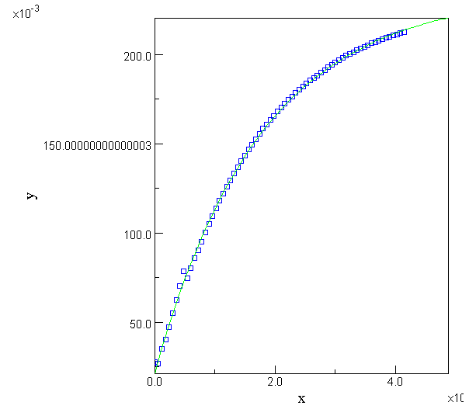
One thing that could have had a small effect on the calculated rate constant could have been the standardization of the pH meter. During the standardization, the pH meter was unable to be standardized with the calibration buffer solutions. If the error in the standardization was on the low side, the reaction may not have went to completion. This, however, should only have a limited effect on the calculated rate constant.

The semi-empirical calculations of the Schrödinger equation gave some insight into the process of the reaction. At the beginning of the reaction, the structure of aspirin was considered.
The bond lengths were calculated in angstroms. There is a difference in the two CO bonds of the carboxyl group. This difference could be because (a) has true carbonyl sp² hybridized character, while (b) has is actually sp³ hybridized forming resonance character.
In the intermediate the CO bond lengths have changed from that in the aspirin. The O(c) has a shorter bond with the ring carbon and a longer bond with the acetyl carbon. There is also a lengthening in the carbonyl bond of the intermediate, and there is a forming of a new bond with the attacking base. The lengthening of the CO(d) bond is due to the intermediate’s new hybridization, from sp² to sp³. The sp³ hybridization can be seen because the molecule is not in the same plane.
Lastly, the products of hydrolysis were considered. Once again, the bond lengths change. The O(c) bond with the ring has lengthened, as has the new bond between O(e) and the carbonyl carbon. Also the carbonyl double bond has shortened on its reformation. The acetyl group has also regained its sp² hybridization that it had at the beginning of the reaction.
In organic chemistry, this reaction is known as a nucleophilic acyl substitution, due to the substitution of a hydroxide at the acyl group of acetate, in place of the ester.

Conclusion
In conclusion, a base-catalyst can be seen to quicken the hydrolysis of aspirin. Using the Cary 50 UV/vis spectrophotometer and knowing that this is a first-order reaction, the rate constant for the base-catalyzed hydrolysis of aspirin can be determined to be k=0.00056684 +- 0.0000072 s⁻¹.
Also, using the Agui 8.16 software package, approximate solutions to approximations of the Schrödinger equation can be used to consider the bond lengths and hybridizations of the compound(s) involved in the reaction. The compounds’ bond lengths follow the trend set by hybridization, as the hybridization goes to a higher number of single bonds, the bond lengths tend to get longer. The molecule in the acetate product has shorter bond lengths than the intermediate. The product has sp² hybridization whereas the intermediate has sp³ hybridization.

