PROBLEM 1
NBC TV news, in a segment of the price of gasoline, reported last evening that the mean price nationwide is $1.50 per gallon for self-serve regular unleaded. A random sample of 35 stations in the Milwaukee, WI area revealed that the mean price was $1.52 per gallon and that the standard deviation was $0.05 per gallon. At the .05 significance level, can we conclude that the price of gasoline is higher in the Milwaukee are? Calculate the p-value and interpret.
Problem 3
Babsie is a public affairs specialist at Park University. A press release issue by Babsie based on some research claims that Park University students study at least as much as the national average for students at four year universities. Across the nation, 73 percent of all students at four year universities study at least four hours per week. Seventy percent of one hundred randomly selected Park University students surveyed claimed to study more than four hours per week. Should the university retract its previous statement? Explain why or why not. (Answer using a 95 percent confidence interval.)
From Textbook P. 426 # 35. 6th Edition Basic Statistics for Business & Economics Lind. Marchal and Wathen. McGraw- Hill.
A regional commuter airline selected a random sample of 25 flights and found that the correleation between the number of passengers and the total weight, in ponds, of luggage stored in the luggage compartment is 0.94. Using the .05 significance level, can we conclude that there is a positive association between the two variables?
S. No. | Movie | Budget ($ million) | Box Office ($ million) | Year
1 | Star Wars | 11 | 1153 | 1977
2 | E.T. | 54 | 915 | 1962
3 | Titanic | 200 | 839 | 1997
4 | The Empire Strikes Back | 18 | 624 | 1980
5 | Return of the Jadi | 33 | 599 | 1983
6 | Jurassic Park | 63 | 546 | 1993
7 | Star Wars Episode 1 | 110 | 544 | 1990
8 | Forrest Group | 55 | 500 | 1994
9 | The Long King | 97 | 474 | 1994
10 | Shrek 2 | 75 | 415 | 2004
11 | Spider Man | 139 | 446 | 2002
12 | Independence Day | 75 | 444 | 1996
13 | Horse Alone | 101 | 427 | 1990
14 | Pirates of the Caribbean: Dead Man’s Chest | 225 | 423 | 2006
15 | LOTR: The Retern of the King | 94 | 401 | 2003
16 | Spider Man 2 | 200 | 385 | 2004
17 | The Person of the Christ | 25 | 382 | 2004
18 | Star Wars: Episode 2 | 115 | 380 | 2005
19 | The Lord of the Rings: The Two Towers | 94 | 376 | 2002
20 | The South scene | 40 | 370 | 1999
21 | Finding Memo | 94 | 361 | 2003
22 | Harry Porter and the Sorceress Store | 130 | 360 | 2001
23 | The Lord of the Ring: The Fellowship of the Ring | 109 | 355 | 1997
24 | Man in Black | 90 | 349 | 2002
25 | Star Wars Episode 1- Attack of the Clones | 120 | 343 | 1992
26 | Aladdin | 28 | 331 | 1990
27 | Ghost | 22 | 326 | 2003
28 | Pirates of the Caribbean | 125 | 325 | 1997
29 | The Loss World | 78 | 320 | 1991
30 | Terminator 2- Judgment Day | 100 | 328 | 2000
31 | The Metric Reloaded | 127 | 299 | 2006
32 | The Chronicles of Narnia | 180 | 292 | 2005
33 | Harry Porter and the Goblet of fire | 140 | 290 | 2001
34 | Monstern’s inc. | 115 | 290 | 2002
35 | Harry Porter and the Chamber of Secrets | 100 | 290 | 2004
36 | Meet the Factors | 80 | 288 | 1998
37 | Armageddon | 140 | 276 | 2004
38 | The Incredible | 92 | 270 | 2004
39 | Harry Porter and the Prisoner of Azkabon | 130 | 257 | 2000
40 | Mission Impossible 2 | 125 | 256 | 2006
41 | Night at the Museum | 120 | 246 | 2005
42 | War of the World | 128 | 234 | 2005
43 | King Kong | 207 | 218 | 2005
44 | The da Vincicode | 125 | 218 | 2005
45 | Ice Age: The Meltdown | 80 | 195 | 2005
 | Medagascar | 124 | 193 | 2005
 | The Day After Tomorrow | 125 | 193 | 2004
 | Casino Royale | 150 | 167 | 2006
 | Troy | 155 | 138 | 2004
Find the correlation between the world box office budget and world box office sales. Comment on the association between the two variables. Can we conclude that there is a significant negative correlation between movies with large budgets and large box office revenues?
53. The following data shows the retail price for 12 randomly selected laptop computers along with their corresponding processor speeds in gigahertz.
Computer | Speed | Price | Computer | Speed | Price
1 | 2.0 | $2659 | 7 | 2.0 | 2929
2 | 1.6 | 1229 | 8 | 1.6 | 1849
3 | 1.6 | 1419 | 9 | 2.0 | 2819
4 | 1.0 | 1589 | 10 | 1.6 | 2669
5 | 2.0 | 1849 | 11 | 1.0 | 1249
6 | 1.2 | 1349 | 12 | 1.4 | 1159

- Develop a linear equation that can be used to describe how the price depends on the processor speed. E
- Based on your regression equation, is there one machine that seems particularly over or under priced?
- Compute the correlation coefficient between the two variables. At the .05 significance level conduct a test of hypothesis to determine if the population correlation could be greater than zero.

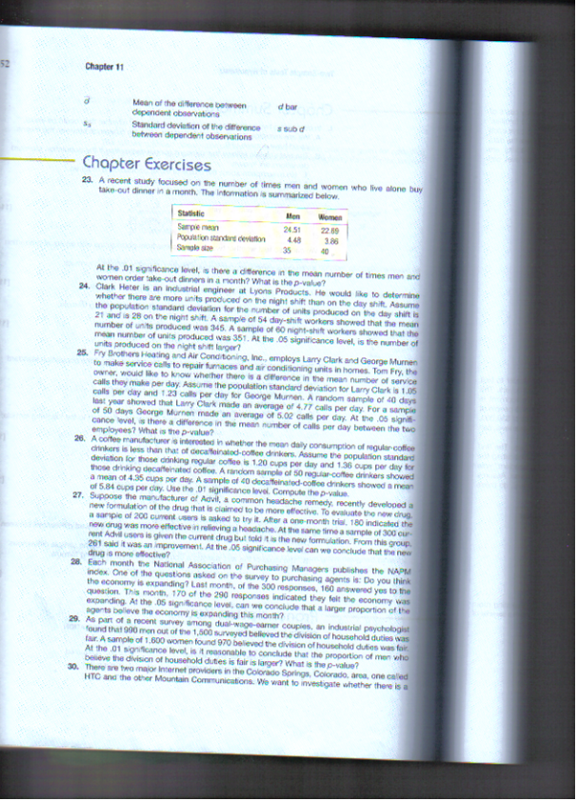
Pg. 353 #34
A number of automobile accidents occur at various high-risk intersections in Teton country despite traffic lights. The traffic department claims that the modification in the type of light will reduce these accidents. The country commissioners have agreed to the proposed increment. Eight intersections were chosen at random and the lights at those intersections were modified. The numbers of minor accidents during six month period, before and after the modifications were-
The sample is 60 night-shift workers. Ismik
Number of Accidents
 | A | B | C | D | E | F | G | H
Before modification | 5 | 7 | 6 | 4 | 8 | 9 | 8 | 10
After modification | 3 | 7 | 7 | 0 | 4 | 6 | 8 | 2
As the 0.1 significance level is it reasonable to conclude that the modification reduces the number of accidents?
Laster Holla is the vice president for human resource for a large manufacturing company. In recent years, he has noticed an increase in absenteeism that he thinks is related to the general health of the employees. Four years ago, in an attempt to improve situation, he began a fitness program in which employees exercise during their lunch hour.
Pg. #355 #40
At the 0.05 significance level, can we conclude the contaminations in measurements are lower after the use of new soap?
40. the following data on annual rates of return were collected from live stocks listed on the New York Stock Exchange (the big board) and live stock listed on NASDAQ. Assume the population standard deviation are the same. At the 10, significance level, can we conclude that the annual rates of rectum are higher on big board?
NYSE | NASDAQ
17.16 | 15.80
17.06 | 15.28
15.51 | 10.21
8.43 | 17.97
25.15 | 7.77

