EXERCISE 5–6 Cost Behavior; Contribution Format Income Statement
Parker Company manufactures and sells a single product. A partially completed schedule of the company's total and per unit costs over a relevant range of 60,000 to 100,000 units produced and sold each year is given below:
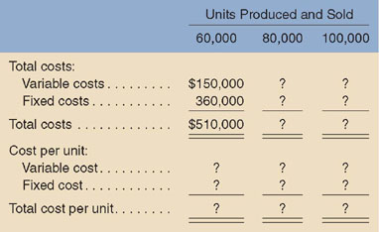(K)
Required:
- Complete the schedule of the company's total and unit costs above.
- Assume that the company produces and sells 90,000 units during the year at the selling price of $7.50 per unit. Prepare a contribution format income statement for the year.

