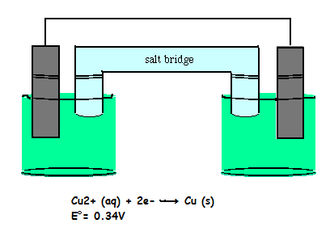
The cell shown above is a concentration cell. Both cells contain copper solutions and have copper electrodes. The only driving force for this cell is the difference in the concentration of the copper solutions. The system will react to equalize the concentration of the ions in both cells. Calculate ξ, the electromotive force, for the concentrations listed below, in the overall reaction.
Oxidation: Cu (s) → Cu²⁺ (aq) + 2 e⁻
Reduction: Cu ²⁺ (aq) + 2 e⁻ → Cu (s)
Overall : Cu ²⁺ (aq) [2.62 M] + Cu(s) → Cu (s) + Cu ²⁺ (aq) [1.41 M]
ξº_{cell} is zero in concentration cells, because the same reaction is occuring at the anode and cathode.
ξº_{cell} = ξº_{reduction} - ξº _{oxidation} = 0.
Use the Nernst equation to calculate ξ for the cell above at 298 K.
ξ = ξº - (RT/nF) ln Q
Calculate ξ for the cell above. Use V for the units.

