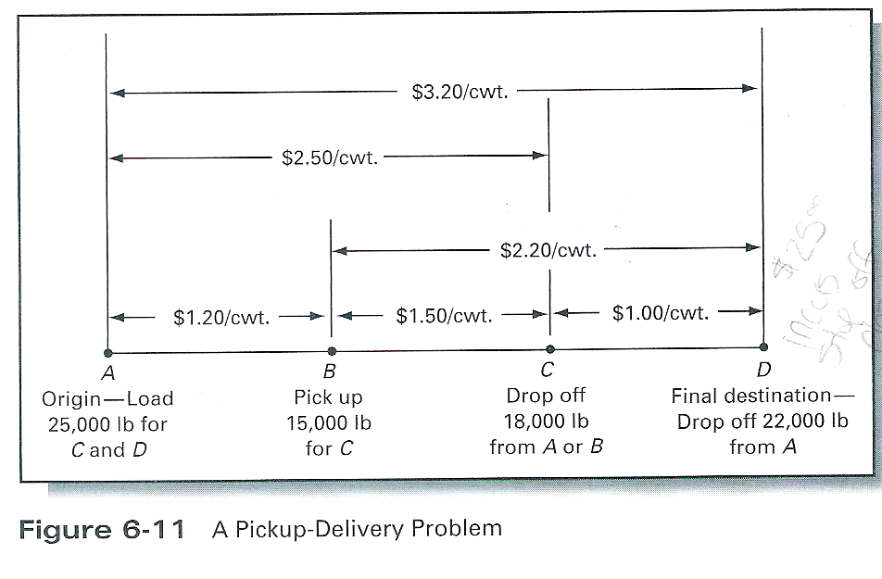

Transport Decisions Figure
Transport Mode | Transit Time, Days | Rate, $/Unit | Shipment Size, Units
Rail | 16 | 25.00 | 10,000
Piggyback | 10 | 44.00 | 7,000
Truck | 4 | 88.00 | 5,000

