The following cost data relate to the manufacturing activities of Black Company during the just completed year:
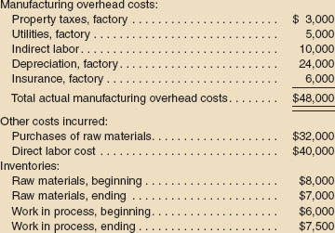(K)
The company uses a predetermined overhead rate to apply overhead cost to production. The rate for the year was $5 per machine-hour; a total of 10,000 machine-hours was recorded for the year. All raw materials ultimately become direct materials—none are classified as indirect materials.
Required:
- Compute the amount of underapplied or overapplied overhead cost for the year.
Prepare a schedule of cost of goods manufactured for the year.

