Name:

MTH133

Unit 2 Individual Project

Name:

1) Solve the following by factoring; find the solutions, factoring alone is not the objective of the problems:

a) 

Answer:

Show your work here:

b) 

Answer:

Show your work here:

2) If , find:

a) *f*(2)

Answer:

Show your work here:

b) *f*(-3)

Answer:

Show your work here:

3) Solve  using the quadratic formula.

Answer:

Show your work here:

4) Use the graph of  to answer the following:

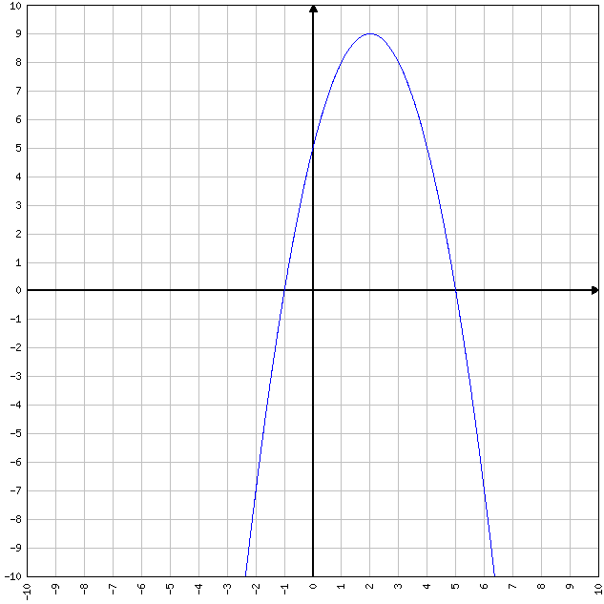

a) Without solving the equation, or factoring, determine the solution(s) to the equation  using only the graph.

Answer:

Explain how you obtain your answer(s) by looking at the graph:

b) Which does this function have, a maximum or a minimum?

Answer:

Explain how you obtain your answer by looking at the graph:

c) What are the coordinates of the vertex in (*x, y*) form?

Answer:

d) What is the equation of the line of symmetry for this graph?

Answer:

5) a) Calculate the value of the discriminant of  .

Answer:

Show your work here:

b) By examining the sign of the discriminant in part a, how many *x*-intercepts would the graph of have? Why?

Answer:

6) a) Find the corresponding y values for *x*= -2, -1, 0, 1, 2, 3 if.

Answer (fill in y column)

|  |  |
| --- | --- |
| ***x*** | ***y*** |
| -2 |  |
| -1 |  |
| 0 |  |
| 1 |  |
| 2 |  |
| 3 |  |

Show your work here: (type *x*-squared as *x*^2 unless using a superscript feature).

b) Use Microsoft Excel or another web-based graphing utility to plot the points found in part a and to sketch the graph. Read the information in the assignments list to learn more about how to graph in MS Excel.

7) The path of a falling object is given by the function  where represents the initial velocity in ft/sec and represents the initial height in feet.

a) If a rock is thrown upward with an initial velocity of 64 feet per second from the top of a 25-foot building, write the height (s) equation using this information.

Typing hint: Type *t*-squared as *t*^2

Answer:

b) How high is the rock after 1 second?

Answer:

Show your work here:

c) After how many seconds will the graph reach maximum height?

Answer:

Show your work here:

d) What is the maximum height?

Answer:

Show your work here: