MTH133

Unit 1 Individual Project –

**Name:**

1) Solve the following algebraically. Trial and error is not an appropriate method of solution. You must show all of your work:

a) 2*x* + 5 = 9

Answer: x=2

Show your work here: 2x=9-5

X=4/2

X=2

b) 

Answer: x=-3

Show your work here: -6x – 6+4= 16

-6x-2 = 16

X= -18/6

X= -3

c) 

Answer: x=60

Show your work here: 12[ 3/4x-5] = 12 [ 2/3 x]

9x-60=8x

9-8x= 60

X=60

d) 

Answer:

Show your work here:

2) a) Solve  for *y*

Answer:

Show your work here:

b) When graphed this equation would be a line. By examining your answer to part a, what is the slope and *y*-intercept of this line?

Slope = ______

*Y*-intercept = _____

c) Using your answer from part a, find the corresponding value of *y* when *x* =12.

Answer:

Show your work here:

3) The following graph shows Bob’s salary from the year 2002 to the year 2005. He was hired in the year 2002; therefore *x* = 0 represents the year 2002.



a) List the coordinates of any two points on the graph in (*x, y*) form.

(_1, _2_),(_2_, _3_)

b) Find the slope of this line:

Answer: 1

Show your work here: m= 3-2/ 2-1= 1

c) Find the equation of this line in slope-intercept form.

Answer: y= 1x + 1

Show or explain your work here: y=mx+b 2-1=b

Y=1(x)+b 1=b

2= 1(1)+b

d) Using the result in part c, determine Bob’s salary, in dollars, in 2008.

Answer:

Show or explain your work here:

4) Suppose that the length of a rectangle is 3 inches longer than the width and that the perimeter of the rectangle is 78.

a) Set up an equation involving only *W*, the width of the rectangle.

Answer:

b) Solve this equation algebraically to find the length of the rectangle. Find the width as well. Use the appropriate units of measure in you answers.

Answer: Length ______, Width ______

Show your work here:

5) A tennis club offers two payment options:

Option1: $35 monthly fee plus $4/hour for court rental

Option 2: No monthly fee but $6.50/hour for court rental.

Let *x* = hours per month of court rental time.

1. Write a mathematical model representing the total monthly cost, *C*, in terms of *x* for the following:

Option 1: *C*=_________________

Option 2: *C*=_________________

1. How many hours would you have to rent the court so that the monthly cost of option 1, is less than option 2. Set up an inequality and show your work algebraically using the information in part a.

Answer:

Show your work here:

1. Plot the following points on the given rectangular coordinate system by clicking on the given dots and dragging them.



Points to plot:

(-3, -2 )

(-1, 0)

(1, 2)

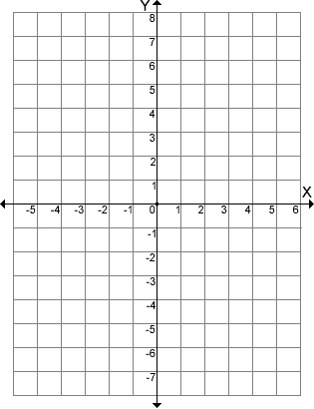

If you were to connect these points with a line, where would the *y*-intercept be located? Give answer in (*x*, *y*) form.

(___, ___)