CHAPTER E-TEXT QUESTIONS
If the problem requires a Hypothesis test, complete the 5-Step Hypothesis testing procedure for each question and then answer the questions of the problem.
1. Write a Null and Alternative Hypothesis
2. Select a Level of Significance
3. Choose a Test Statistic
4. Write a decision rule for the computed test statistic
5. Make a decision by computing the test statistic and comparing it to the decision rule spelling out in English just what the decision means in terms of the question in the problem.
Note: Methods of computation could include the usage of Excel®, SPSS®, Lotus®, SAS®, MINITAB®, or by hand computation.

CHAPTER 12

Review Exercise
1. (a) How does correlation analysis differ from regression analysis? (b) What does a correlation coefficient reveal? (c) State the quick rule for a significant correlation and explain its limitations. (d) What sums are needed to calculate a correlation coefficient? (e) What are the two ways of testing a correlation coefficient for significance?

12.48 In the following regression, X = weekly pay, Y = income tax withheld, and n = 35 McDonald’s employees. (a) Write the fitted regression equation. (b) State the degrees of freedom for a two-tailed test for zero slope, and use Appendix D to find the critical value at α = .05. (c) What is your conclusion about the slope? (d) Interpret the 95 percent confidence limits for the slope. (e) Verify that F = t2 for the slope. (f) In your own words, describe the fit of this regression.

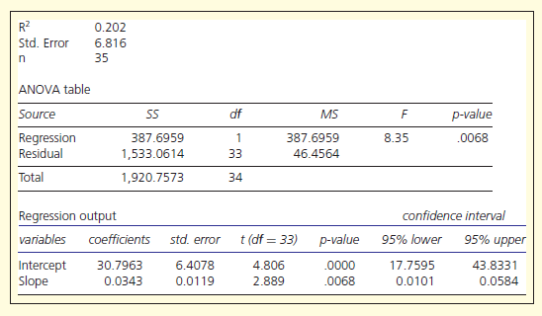

12.50 In the following regression, X = total assets ($ billions), Y = total revenue ($ billions), and n = 64 large banks. (a) Write the fitted regression equation. (b) State the degrees of freedom for a two- tailed test for zero slope, and use Appendix D to find the critical value at α = .05. (c) What is your conclusion about the slope? (d) Interpret the 95 percent confidence limits for the slope. (e) Verify that F = t2 for the slope. (f) In your own words, describe the fit of this regression.

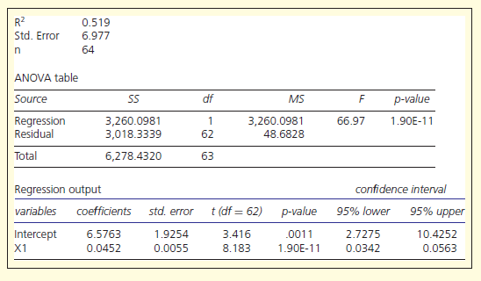

CHAPTER 13

13.30 A researcher used stepwise regression to create regression models to predict BirthRate (births per 1,000) using five predictors: LifeExp (life expectancy in years), InfMort (infant mortality rate), Density (population density per square kilometer), GDPCap (Gross Domestic Product per capita), and Literate (literacy percent). Interpret these results.

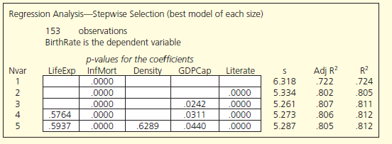

13.32 An expert witness in a case of alleged racial discrimination in a state university school of nursing introduced a regression of the determinants of Salary of each professor for each year during an 8-year period (n = 423) with the following results, with dependent variable Year (year in which the salary was observed) and predictors YearHire (year when the individual was hired), Race (1 if individual is black, 0 otherwise), and Rank (1 if individual is an assistant professor, 0 otherwise). Interpret these results.

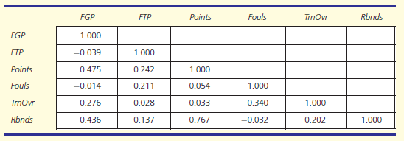

CHAPTER 14

14.16 (a) Plot the data on U.S. general aviation shipments. (b) Describe the pattern and discuss possible causes. (c) Would a fitted trend be helpful? Explain. (d) Make a similar graph for 1992–2003 only. Would a fitted trend be helpful in making a prediction for 2004? (e) Fit a trend model of your choice to the 1992–2003 data. (f) Make a forecast for 2004, using either the fitted trend model or a judgment forecast. Why is it best to ignore earlier years in this data set?

