Name:

MTH133

Unit 2 – Individual Project – A

**Name:**

1) Solve the following by factoring:

a) 

Answer:

Show your work here:

b) 

Answer:

Show your work here:

2) If , find

a) *f*(2)

Answer:

Show your work here:

b) *f*(-1)

Answer:

Show your work here:

3) Solve 6*x*2 + 3*x* – 18 = 0 using the quadratic formula.

Read the information in the assignment list to learn more about how to type math symbols, such as the square root.

Answer:

Show your work here:

4) Use the graph of *y* = *x*2 + 4*x* - 5 to answer the following:

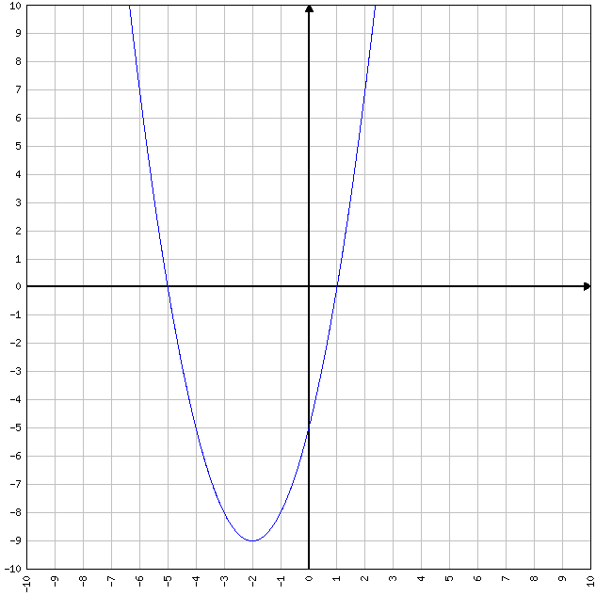

a) Without solving the equation or factoring, determine the solution(s) to the equation, , using only the graph.

Answer:

Explain how you obtained your answer(s) by looking at the graph:

b) Does this function have a maximum or a minimum?

Answer:

Explain how you obtained your answer by looking at the graph:

c) What are the coordinates of the vertex in (*x*, *y*) form?

Answer:

d) What is the equation of the line of symmetry for this graph?

Answer:

5)

a) Calculate the value of the discriminant of .

Answer:

Show your work here:

b) By examining the sign of the discriminant in part a, how many *x*-intercepts would the graph of have? Why?

Answer:

6) a) Find the corresponding *y* values for *x* = -4, -3, -2, -1, 0, 1, 2 if.

Answer (fill in *y* column)

|  |  |
| --- | --- |
| ***x*** | ***y*** |
| - 4 |  |
| - 3 |  |
| - 2 |  |
| - 1 |  |
| 0 |  |
| 1 |  |
| 2 |  |

Show your work here: (type *x*-squared as *x*^2 unless using a superscript feature).

b) Use Microsoft Excel to plot the points found in part a and to sketch the graph.

Read the information in the assignment list to learn more about how to graph in MS Excel.

Graph:

7) The path of a falling object is given by the function  where represents the initial velocity in ft/sec and represents the initial height. The variable *t* is time in seconds, and *s* is the height of the object in feet.

a) If a rock is thrown upward with an initial velocity of 32 feet per second from the top of a 40-foot building, write the height equation using this information.

Typing hint: Type *t*-squared as *t*^2.

Answer:

b) How high is the rock after 0.5 seconds? Show all work.

Answer:

Show your work here:

c) After how many seconds will the rock reach maximum height? Show all work.

Answer:

Show your work here:

d) What is the maximum height? Show all work.

Answer:

Show your work here: