1-In the formula A = I^{ekt} , A is the amount of radioactive material remaining from an initial amount I at a given time t and k is a negative constant determined by the nature of the material. An artifact is discovered at a certain site. If it has 53% of the carbon-14 it originally contained, what is the approximate age of the artifact? (carbon-14 decays at the rate of 0.0125% annually.) (Round to the nearest year.)
4240 yr
5079 yr
2206 yr
3760 yr

2-Suppose the amount of a radioactive element remaining in a sample of 100 milligrams after x years can be described by A(x) = 100e^{-0.01657x} . How much is remaining after 257 years? Round the answer to the nearest hundredth of a milligram.
425.85 milligrams
7070.31 milligrams
1.41 milligrams
0.01 milligrams

3-Use a graphing calculator to predict about how many books will have been read in the eighth grade.
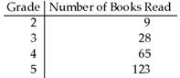
1000
2000
3000
500

4-Write the logarithmic and exponential equations associated with the display.
g(x) = ln x
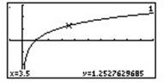
ln 3.5 = .54406804435; e^{.54406804435} = 3.5
ln .54406804435 = 3.5; e^{3.5} = .54406804435
ln 3.5 = 1.2527629685; e^{1.2527629685} = 3.5
ln 1.2527629685 = 3.5; e^{3.5} = 1.2527629685

5-Write the logarithmic and exponential equations associated with the display.
f(x) = log x
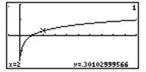
log .301029995664 = 2; 10² = .301029995664
log .69314718056 = 2; 10² = .69314718056
log 2 = .301029995664; 10^{.301029995664} =2
log 2 = .69314718056; 10^{.69314718056} = 2

6-Write the logarithmic and exponential equations associated with the display.
f(x) = log x
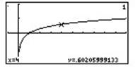
log 4 = .602059991328; 10^{.602059991328} = 4
log .602059991328 = 4; 10⁴ = .602059991328
log 1.38629436112 = 4; 10⁴ = 1.38629436112
log 4 = 1.38629436112; 10^{1.38629436112} = 4

