*1. Disregard

2. Simplify the following expression:

3.
The surface area of a right prism is given by
,
where is the area of the base, is the perimeter of the base, and is the height of the prism.
Solve for .
4. Solve the following equation for .
Simplify your answer as much as possible.

5. Graph the line.
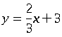

6. Disregard

7. Find the values of and that solve the following system of equations:
.

8. Express the following product of powers of as a single power of :
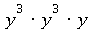 .

9. Simplify the following:
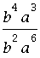

10. Write without parentheses:
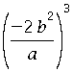 .

11. Rewrite the following without an exponent:
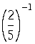 .

12. Simplify.
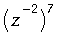
Write your answer without using negative exponents.

*13. Disregard

14. Simplify the following:

15. Perform the following multiplications.
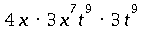
Simplify your answer as much as possible.

16. Write the product below in simplest form without parentheses:
.

17. Rewrite without parentheses and simplify.
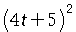

18. Multiply:
.
Simplify your answer as much as possible.

19. Factor
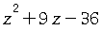 .

20. Factor.
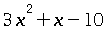

21. Factor:
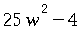

22. Factor:
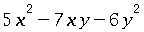

23. Factor:
.

24. Multiply. Write your answer in lowest terms.
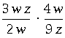

25. Express the following compound fraction in lowest terms:
.
26. Subtract. Write your answer in lowest terms.
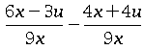
27. Add and simplify:
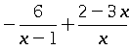
28. Reduce the following expression to lowest terms:
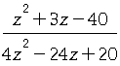

29. Solve for :
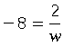 .
Simplify your answer as much as possible.

30.
Find all values of satisfying the equation
.
(If there is more than one solution, separate them with commas.)

31. Solve the following proportion for .
Round your answer to the nearest tenth.

32. Heather drove miles using gallons of gas. At this rate, how many miles would she drive using gallons of gas?

33. Rewrite the following in simplified radical form.

34.
Simplify:
Assume that the variable represents a positive real number.

35. Simplify.

36. Write without exponents:
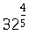 .

37. Rewrite the following in simplified radical form.
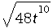
Assume that all variables represent positive real numbers.

38. Simplify the following expression as much as possible:
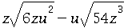
Assume that all variables represent positive real numbers.
39. Simplify.
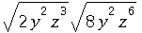
Assume that all variables represent positive real numbers.

40. Rationalize the denominator and simplify:
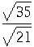 .

41. Solve for :
,
where is a real number.
(If there is more than one solution, separate them with commas.)

42. Solve the following equation for :
,
where is a real number.
(If there is more than one solution, separate them with commas.)

*43. Disregard

44. Compute the following:
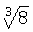.
45. Write the following expression in simplified radical form.
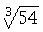

46. Find the roots of the quadratic equation:
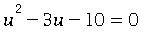 .
(If there is more than one root, separate them with commas.)

47. Find the roots of the quadratic equation:
.
(If there is more than one root, separate them with commas.)

48. Solve 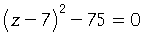where is a real number.
Simplify your answer as much as possible.
(If there is more than one solution, separate them with commas.)

49. Solve the following equation for by using the quadratic formula:
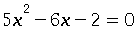 .
(If there is more than one solution, separate them with commas.)

50. Disregard

