- Rewrite the following in simplified radical form.
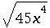
Assume that all variables represent positive real numbers

- Write the following expression in simplified radical form.
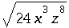
Assume that all variables represent positive real numbers.

- Simplify the following expression as much as possible:
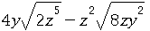
Assume that all variables represent positive real numbers.

4.
Simplify.
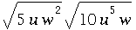
Assume that all variables represent positive real numbers.

5.
Multiply. Simplify your answer as much as possible.

6.
Rationalize the denominator and simplify:
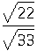

7.
Write in simplified radical form by rationalizing the denominator.
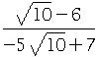

8.
Solve for :
,
where is a real number.
(If there is more than one solution, separate them with commas.)

9.
Solve the following equation for :
,
where is a real number.
(If there is more than one solution, separate them with commas.)

10.
Solve for :
,
where is a real number.
(If there is more than one solution, separate them with commas.)

11.
For the following right triangle, find the side length . Round your answer to the nearest tenth.

12.
Compute the following:
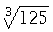.

13.
Write the following expression in simplified radical form.
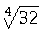

14.
Write the following expression in simplified radical form.
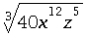
Assume that all of the variables in the expression represent positive real numbers.

15.
Find the roots of the quadratic equation:
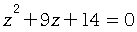 .
(If there is more than one root, separate them with commas.)

16.
Solve:
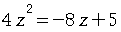 .
(If there is more than one solution, separate them with commas.)

17.
Solve the equation
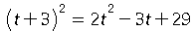
for .
(If there is more than one solution, separate them with commas.)

18.
Solve 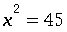 , where is a real number.
Simplify your answer as much as possible.
(If there is more than one solution, separate them with commas.)

19.
Solve 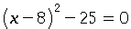where is a real number.
Simplify your answer as much as possible.
(If there is more than one solution, separate them with commas.)

20.
Compute the value of the discriminant and give the number of real solutions to the quadratic equation
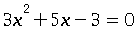

21.
Solve the following equation for by using the quadratic formula:
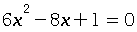 .
(If there is more than one solution, separate them with commas.)

22.
When a ball is thrown, its height in feet after seconds is given by the equation
,
where is the initial upwards velocity in feet per second. If feet per second, find all values of for which feet. Do not round any intermediate steps. Round your answer to decimal places.
(If there is more than one answer, enter additional answers with the button that says "or".)

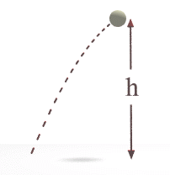

23.
Graph the parabola:
.
To graph the parabola, plot the vertex and four additional points, two on each side of the vertex, and then click on the graph icon.

24.
Graph the parabola:
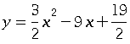 .
To graph the parabola, plot the vertex and four additional points, two on each side of the vertex, and then click on the graph icon.

.

25.
Find the -intercept(s) and the coordinates of the vertex for the parabola . If there is more than one -intercept, separate them with commas.

