#1. Multiply. Write your answer in lowest terms.
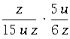

#2. Multiply and simplify:
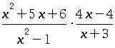

#3. Divide. Write your answer in lowest terms.
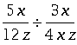

#4. Express the following compound fraction in lowest terms:
⁴ .
28 ⁹
⁴ ³
3 r s
²
7 pq
6 r ³
^{s}

#5. Simplify as much as possible
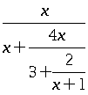

#6. Add. Write your answer in lowest terms.
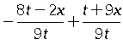

#7.Express as a single fraction in lowest terms:
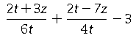

#8. Subtract and simplify:
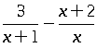

.
9. Add and simplify:
3 2
------------------------- + ----------------------------
5 x ² - 33 x + 54 5 x ² - 38 x + 72

10. Reduce the following expression to lowest terms:
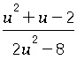

11. Reduce the following rational expression to its lowest terms:
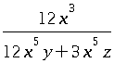

12. Solve for :
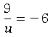 .
Simplify your answer as much as possible.

13. Solve the following equation for :
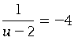 .
Simplify your answer as much as possible.

14. Find all values of satisfying the equation
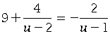.
(If there is more than one solution, separate them with commas.)

15. Find all values of which satisfy the equation
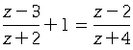.
(If there is more than one solution, separate them with commas

16. Solve the following proportion for .
Round your answer to the nearest tenth.

17. Solve the following proportion for :
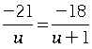

18. There is a sales tax of on an item that costs before tax. A second item costs before tax. What is the sales tax on the second item?

19. A swimming pool holds liters of water. The pool has two drainage pipes. When the pool is completely full, the first pipe alone can empty it in minutes, and the second pipe alone can empty it in minutes. When both pipes are draining together, how long does it take them to empty the pool?

20. If the expression:
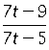
is to make sense, the values that can take must be restricted. State the restriction on .

