2-3 pages with Excel Graphs

Great news! ABC Advertising has called you in for an interview to join their advertising team. During the interview process, you are expected to solve a linear regression problem. Consider the following data in the table below that show U.S. advertising expenditures in millions of the current U.S. dollars.
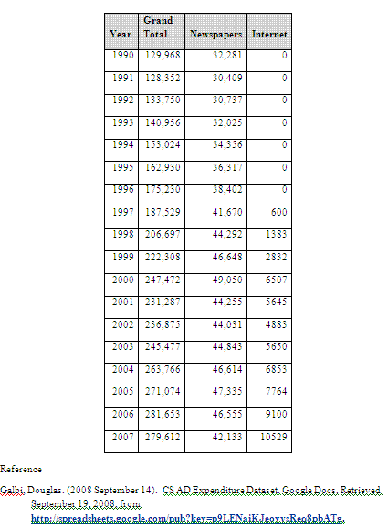

Based on these data, please supply the following:
- Provide graphs of Grand Total versus Year, Newspapers versus Year, and Internet versus Year.
- Which advertising expenditure from #1 has the best linear graph for predicting? Explain.
- Based on your answer for #2, provide a regression equation for the advertising method and explain how well the equation predicts known expenditure values.
- How quickly are expenditures for the advertising method chosen in #2, growing per year? Would you expect this rate to continue? Explain why or why not.
- Complete a 5-year prediction for advertising expenditures for the particular advertising method chosen in #2. Next, complete a 20-year prediction. Explain the validity in these predictions.
- Based on the method chosen in #2, in what year would you expect the Internet expenditures to reach 20,000 (in millions)? Explain the validity of this prediction

