16.
Factor completely:
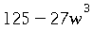 .

17.
Factor:
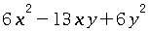.

18.
Find the greatest common factor of the two expressions
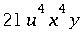and 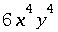.
Simplify your answer as much as possible

19.
Find the least common multiple of the two expressions
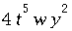and 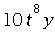.
Simplify your answer as much as possible.

20.
Factor:
.

21.
Factor
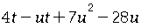
22.
Factor:
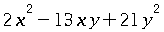

23.
Find the greatest common factor of the two expressions
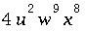and 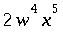.
Simplify your answer as much as possible

24.
Factor:
.

25.
Factor
.

